Flexural Behavior of RC Beams made with Recyclable Aggregates under 12-Month Long Term Loading

Mahboob Oad
Department of Civil Engineering, Quaid-e-Awam University Of Engineering, Science & Technology,
Nawabshah, Pakistan.
engrmahboob04@gmail.com

Abdul Hafeez Buller
Post Graduate Student, Quaid-e-Awam University of Engineering, Science & Technology,
Nawabshah, Pakistan
engrabdulhafeezbuller@gmail.com
Bashir Ahmed Memon
Department.of Civil Engineering, Quaid-e-Awam University of Engineering, Science & Technology,
Nawabshah, Pakistan.
bashir_m@hotmail.com

Noor Ahmed Memon
Department.of Civil Engineering, Quaid-e-Awam University of Engineering, Science & Technology,
Nawabshah, Pakistan.
nahmedmemon@gmail.com

Abstract— Demolishing waste management in present era of infrastructure development has posed serious problems around the globe particularly in urban centers. Also, the pace of development requires huge quantum of conventional aggregates of concrete resulting in serious problems to environment. Therefore, as a remedy to both of the issues demolishing waste; particularly the demolishing concrete; as coarse aggregates; is used in new concrete. Therefore, this article presents laboratory investigations of flexural behavior of reinforced concrete beams made with partial replacement of natural coarse aggregates with coarse aggregates from demolished concrete under 12-month long-term loading. Two batches of beams were cast and cured for 28 days. In first batch three RC beams with partial replacement of natural coarse aggregates were cast, whereas, in second batch 6 RC beams with all-natural coarse aggregates were prepared. Out of these six beams three beams were tested under short-term loading to determine the maximum load. 50% of this load was used as sustained load on remaining all beams. The beams were mounted on purpose made frames to record deflection, strain and cracking on daily basis. After elapse of proposed time the beams were tested in under central point load till failure. The comparison of results show 4.96% increase in deflection and 2.33% reduction in peak load. Based on the results of this study it is concluded that the demolished concrete as coarse aggregates in new concrete shows reasonably good performance under 12-month long-term loading.

Keywords- Recyclable Aggregates; Reinforced Concrete Beam; Demolishing Waste; Flexural Behavior; Long-Term Loading; Green Concrete.

- ntroduction
With time concrete has proved itself as the best material for general construction. But there are several issues related with the production of its ingredients. Like production of cement, production of aggregates using blasting. These processes pose problems to the environment. On the other hand,

demolishing waste generated from demolishing of old structures; to give way to new construction to cope with increasing demand of livable space; also adds up in the environmental issues. To deal with both of the problems; although to some extent; an option is using the waste in new concrete. The resulting product will be eco-friendly, help in waste management and also help in preserving ingredients of conventional concrete for future generations. The concrete using waste material is termed as green concrete. The use of demolished old concrete as coarse aggregates in new concrete has remained active area of research since past few decades. Several scholars have studied this material from recycling to its advance properties and its impact on the concrete produced with it. The study of any aspect of a material requires comprehensive review of the literature related to it. The same is carried out by an author in [1] to check the recent development about the use of demolished concrete as coarse aggregates in new concrete. The author highlighted different aspects of the material with respect to its use and problems associated with it. Based on his review the author is of opinion that the material has promising effect particularly on the strength of concrete.

Concrete testing under short-term loading is routine practice to determine its various properties. In this connection authors in [2, 3] used 50% replacement of natural coarse aggregates with coarse aggregates from demolished concrete to study flexural stress-strain behavior of RC beams. The obtained results showed 8.8% and 11.68% reduction in flexural capacity of 28-day cured normal and rich mix beams respectively. Flexural, shear and bond of the green concrete beams have also been studied by researchers in [5]. In their research investigations, the authors used waste from the testing of cylinders as coarse aggregates in 40% and 100% dosages. The comparison of obtained results with control specimens, ACI provisions and findings from literature showed the authors good agreement of their obtained results.

In real structure mostly the loads are of sustained nature. Therefore, evaluation of material properties and behavior under sustained/long-term loading is essential. To this end authors in [4] used 0%, 50% and 100% dosage of recyclable aggregates from demolished concrete to replace of natural coarse aggregates in casting of reinforced concrete beams. The authors tested the beams with sustained load for 1200 days. Using obtained results, the authors developed numerical expression for evaluation of long-term deflection by introducing creep coefficient of recycled aggregates. The analysis of the results revealed that the size of the aggregates has also influence on the final deflection; therefore, the authors also introduced regeneration co-efficient to deal with the issue. Using the above two coefficients and laboratory data the authors introduced deflection increase coefficient which simplifies computation of long-term deflection. The comparison of the results showed good agreement between two sets. Long-term loading effects; creep and shrinkage; of concrete made with old concrete as coarse aggregates under 365 days sustained loading were compared with ACI provisions [7]. From analysis of the data authors suggested modification in ACI provisions. Testing of the resulting equation showed good agreement between two sets of the results. Long-term behavior of concrete under different conditions has also been studied by several other scholars, i.e. service conditions (cracking and induced stress) of fiber reinforced concrete [8], effect of compressive strength and reinforcement ratio on glass-fiber reinforced concrete [9], numerical expression for effect of bending moment on long-term behavior [10].

From the above discussion it may clearly be observed that still there is need of the research about the use of the material. Therefore, this research article presents laboratory investigation on the effect of 12-month long-term loading on reinforced concrete beams. The 50% replacement [7] of natural coarse aggregates with coarse aggregates from demolished concrete is used in casting of the beams. It is hoped that the outcome of the research will provide detailed understanding of the long-term behavior of the beams for proposed duration and will not only improve the confidence about the material but also set landmark for future research in the field.

II. Material and Testing
The demolished concrete used in this research work was collected in shape of large blocks from demolishing of a five-room single story school building about 45 years old. These blocks were processed manually to reduce up to maximum size of 25 mm (Figure 1). The same size natural coarse aggregates were also used. The remaining ingredients of concrete used in this investigation are ordinary Portland cement, hill sand and potable water (pH=6.87). Although good care is exercised in hammering the large blocks of the demolished concrete yet some of the cracked particles were present. These particles if used in concrete will definitely affect its final strength, therefore, cracked particles, organic impurities; mortar detached have been removed manually, followed by washing of the aggregates.

To ensure the well graded aggregates in concrete, both natural and recyclable aggregates were sieved as per the relevant procedure and specifications of ASTM. Figure 2 shows the gradation curve of both types of aggregates. It may be observed from the figure that both curves follow the same trend which ensures that the aggregates are well graded.

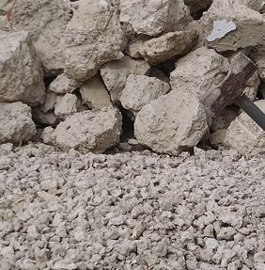
Fig. 1. Demolished concrete

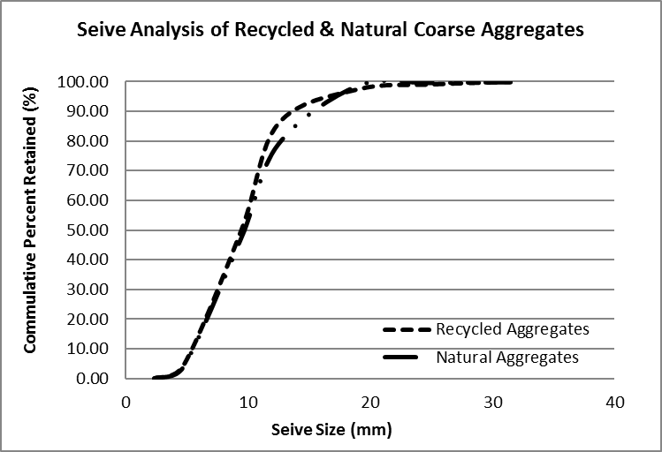
Fig. 2. Sieve analysis of coarse aggregates

The natural and recycled aggregates were used in equal proportion (50%) to cast the reinforced concrete beams. Concrete mix ratio of 1:2:4 with 0.5 water-cement ratio were used. To reinforce the beams grade 60 deformed steel bars were used. The beams were cast in two batches. In first batch three beams were cast with both natural and recycled aggregates, whereas, in second batch six beams were cast with all-natural coarse aggregates. Out of these six beams three beams were used to determine peak load under short-term gradually increasing load. Half of this average load was used as sustained load for long-term testing of the beams. Remaining three beams of this batch were treated as control specimen to check and compare the results of proposed beams. The size of the beams was kept same and equal to 1875 mm x 150 mm x 300mm.

To reinforce the beams four #4 bars were used as longitudinal reinforcement (2 bars in tension and 2 bars in compression zones). Shear reinforcement in the form of stirrups #3 bars was provided at 150 mm center to center along the length of the beams. Deformed bars were used for both longitudinal and shear reinforcement.
For batching of the ingredients weight batching method was adopted. The ingredients were mixed in concrete mixer and placed in moulds following the standard procedure of filling the moulds and to compact the concrete. In all beams top and bottom concrete cover was kept equal to 25 mm. After demolding, all the specimens were cured for 28 days by fully immersing in potable water (Figure 3).

After curing beams were allowed to air dry for 24-hour. To determine the maximum load sustained by the RC beams, three beams made with all-natural coarse aggregates were tested in UTM under central point load (Figure 4). The load is applied gradually at the rate of 0.5 KN/s. The peak load of the three beams was recorded and averaged. 50% of this load was used as sustained load during the long-term testing of proposed parameters.

Dumec pads were applied on all beams along the depth at center with 25 mm center to center distance for strain measurement. All beams were then mounted on purpose made steel frames (figure 5). The load evaluated earlier was applied on center with the help of load cell and screw jack system. This load was kept constant and maintained during the testing time.

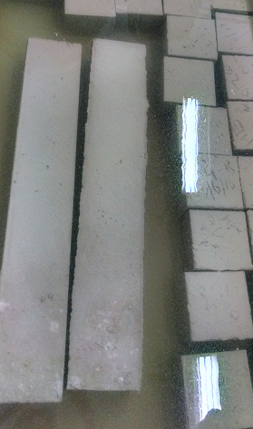
Fig. 3. Curing of specimens

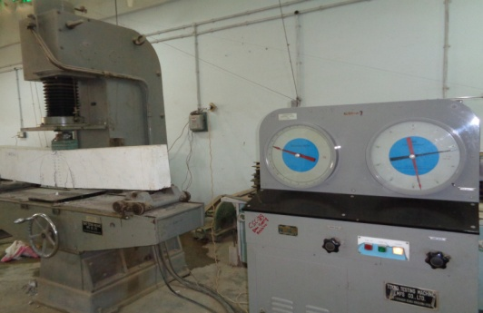
Fig. 4. Short term testing of RC beams

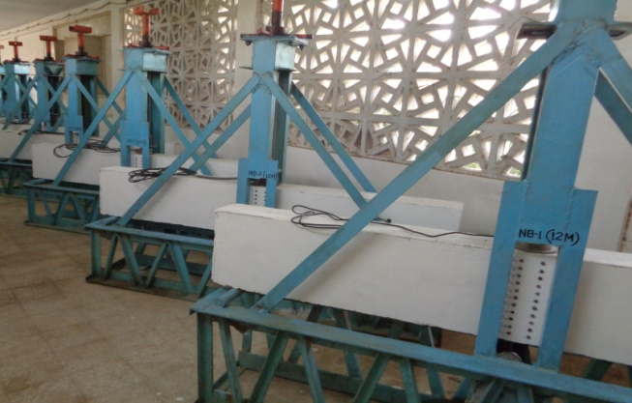
(a)
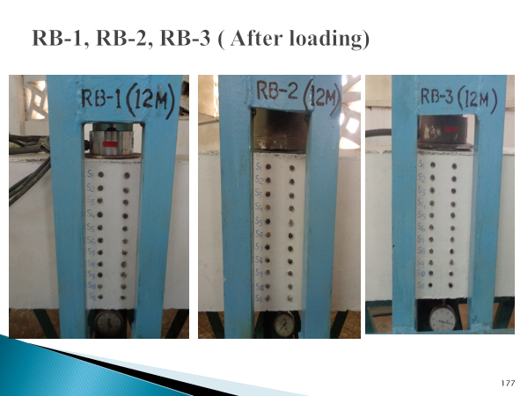
(b)
Fig. 5. Beams under sustained loading (a) & (b)

As aimed, the beams were monitored for deflection, strain and cracking for 12-month on daily basis. At the end of the required time beams were removed from loading frames and tested for peak load in UTM in same fashion as was done to determine the peak load before starting long-term testing of the beams. The obtained results are discussed in following section.
- RESULTS AND DISCUSSION
During the long-term testing of the beams, deflection, strain and cracking were monitored on daily basis. The deflection and strain recorded at eleven locations along the depth of beams at center were averaged. Weekly results of deflection of both groups of beams are shown in Figure 6 and Figure 7. Similarly Figure 8 and Figure 9 show weekly strain of beams cast with all-natural and recycled aggregates. The average values of both of the parameters for all three beams are listed in Table 1. It may be noted that the deflection in beams cast with recyclable aggregates observed 5.6% increase than the deflection observed by control specimens. Whereas, comparison of average strain results shows that proposed beams observed 5.64% increase than control specimens. The observed deflection is also found within limits of the approximate maximum deflection allowed by ACI 318.

To compare the deflection of both groups of beams versus time, the average weekly deflections are plotted in Figure 11. It may be observed that up to deflection of 1.5 mm, stiffness of both of the materials remained same. Beyond this value the beams cast with recyclable aggregates observed more deflection than control specimens. Almost similar trend and behavior was also observed for strain.

The deflection and strain observed during 12-month of proposed beams is also compared with the results presented by authors in [11]. The authors used same material and configuration to study deflection and strain for 6-month sustained loading. The deflection of recyclable concrete beams under 12-month sustained loading observed 17.73% more deflection than the beams under 6-month sustained loading. Similarly increase of 12.83% is observed in strain.

After observations of 12-month under sustained loading, beams were un-mounted from the loading frames and tested in UTM under central point load following the specification provided by ASTM for the purpose. Both load and deflection were monitored in each beam till failure. Figure 11 shows the load Vs deflection of all beams. It may be observed that all the beams observed similar pattern except for peak values. The average ultimate load observed by beams made with all-natural aggregates was recorded equal to 83.38kN. At ultimate load, the average deflection in all three beams of the group was recorded equal to 14.72 mm. Average of both parameters for beams cast with recyclable aggregates were recorded equal to 81.44kN and 15.45 mm respectively. It may be observed that recycled aggregate beams observed 2.33% reduction in load and 4.96% increase in deflection than control specimens.

TABLE I. AVERAGE DEFLECTION AND STRAIN IN ALL BEAMS
Aggregate Type | Deflection (mm) | Strain
Natural | 2.408 | 0.002606
Recycled | 2.543 | 0.002753

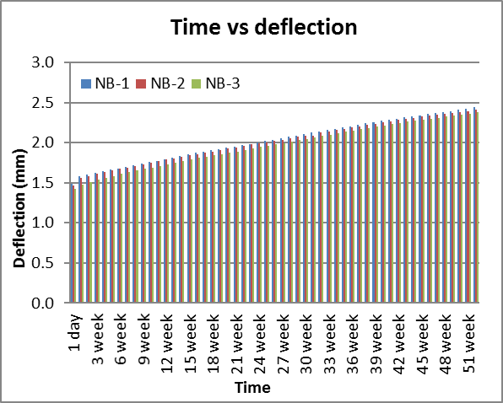
Fig. 6. Weekly deflection (Natural aggregates beams)
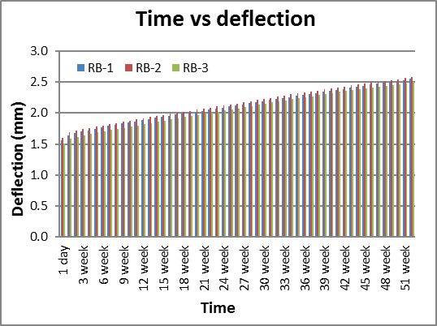
Fig. 7. Weekly deflection (Recycled aggregates beams)

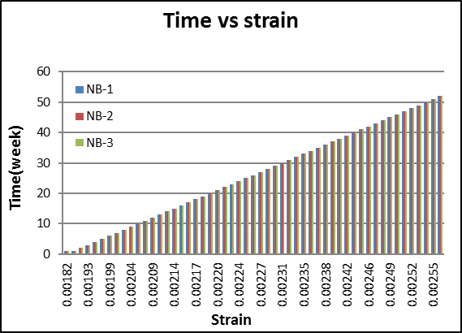
Fig. 8. Weekly strain (Natural aggregates Beams)

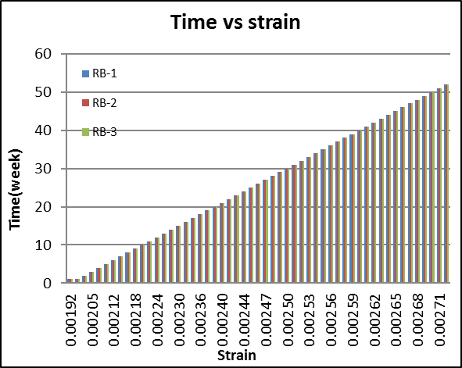
Fig. 9. Weekly strain (Recycled aggregates beams)

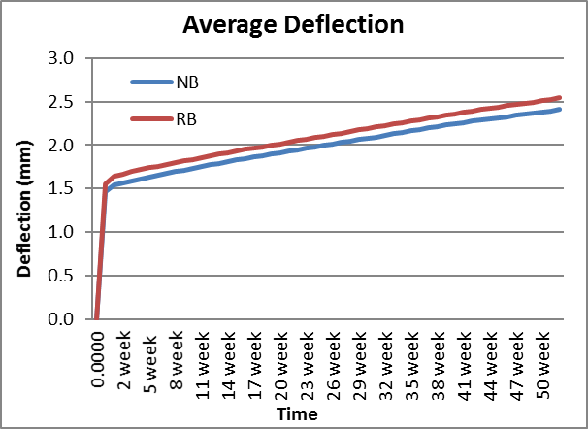
Fig. 10. Average deflection Vs time

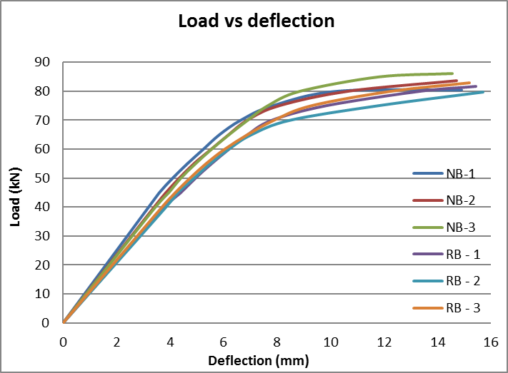
Fig. 11. Load Vs deflection

Cracking due to sustained loadings was monitored. The progression of cracks was also marked and recorded. Figure 12 and Figure 13 show a beam from each group. It may be observed that the cracks pattern of proposed beams (Figure 13) is almost similar to that of beams cast with all-natural aggregates. Also, it is recorded that the crack width at the end of 12-month observations was less than 1 mm. Further, at failure the cracks pattern in the beams was also recorded and displayed in Figure 14 and Figure 15 for a beam from both groups. From the results it may clearly be observed that the response of proposed beams under 12-month loading matches well with control specimens. Hence, 50% replacement of natural coarse aggregates with aggregates from demolished concrete may be used in new concrete.

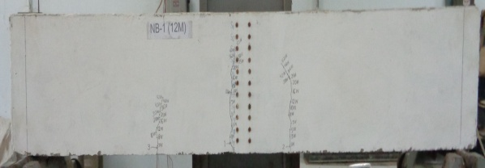
Fig. 12. Cracking NA beam (12-M loading)
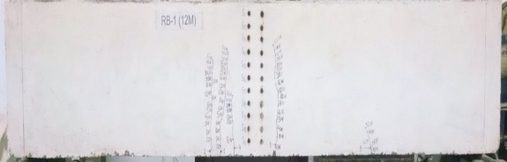
Fig. 13. Cracking RA beam (12-M loading)

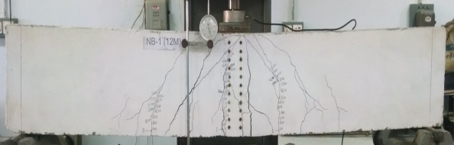
Fig. 14. Cracking NA beam (at failure)
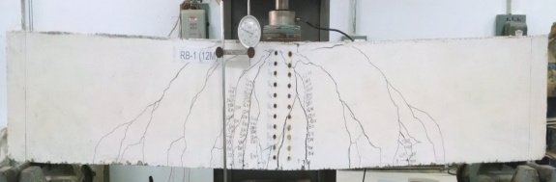
Fig. 15. Cracking RA beam (at failure)

- CONCLUSION
In this research article effect of 12-month sustained loading on reinforced concrete beams made with 50% replacement of natural coarse aggregates with aggregates from demolished concrete is presented. Deflection and strain were measured on daily basis show good agreement with control specimens with deviation under 10%. Also, the crack pattern of proposed beams showed good agreement with control specimens. The maximum crack width after 12-month sustained loading was recorded less than 1 mm. Therefore, it is concluded that the use of demolished concrete as coarse aggregates in new concrete has promising effect.

References
- B. A. Memon, “Recent Development on Use of Demolished Concrete as Coarse Aggregates”, International Journal of Emerging Technology and Innovative Engineering, Vol. 2, No.1, pp: 1 - 11, 2016.
- M. Oad. , A. H. Buller, B. A. Memon , N. A. Memon, S. Sohoo, “Flexural Stress-Strain Behavior of RC Beams made with Partial Replacement of Recyclable Concrete Aggregates, Part-2: Rich Mix”, Engineering Technology and Applied Science Research (ETASR), Vol. 8, No. 5, 2018.
- M. Oad, A. H. Buller, B. A. Memon, N. A. Memon, “Flexural Stress-Strain Behavior of RC Beams made with Partial Replacement of Coarse Aggregates with Coarse Aggregates from Old Concrete Part-1(124 Ratio)”, Engineering Technology and Applied Science Research (ETASR), Vol. 8, No. 3, 2018.
- C. Liu, Z. Y. Lv, C. Zhu, G. L. Bai, Y. Zhang, “Study on Calculaton Method of Long-Term Deformation of RAC Beam based on Creep Adjustment Coefficient”, KSCE Journal of Civil Engineering, Vol. 23, Issue. 1, 2019.
[5] B. S. Hamad, A. H. Dawi, A. Daou, G. R. Chehab, “Studies of the Effect of Recycled Aggregates on Flexural, Shear and Bond Splitting Beam Structural Behavior”, Case Studies in Construction Materials – ELSEVIER, Vol. 9, 2018.
[6] W. C. Choi, H. D. Yun , “Long-Term Deflection and Flexural Behavior of Reinforced Concrete Beams with Recycled Aggregates”, Maerials and Design, Vol. 51, 2013.
[7] M. Oad, B. A. Memon, “Compressive Strength of Concrete Cylinders using Coarse Aggregates from Old Concrete”, 1st National Conference on Civil Engineering (NCCE 2013-14) - (Modern Trends and Advancements), April 28th – 29th, 2014.
[8] D. H. Moneti, L. Torres, M. C. Torrijos, R. Giaccio, R. Marti-Vargas, P. Serna, “Long-Term Behavior of Cracked Fiber Reinforced Concrete under Service Conditions”, Construction and Building Materials, Vol. 196, 2019.
[9] C. Mias, TorresLl, A. Turon, I. A. Sharaky, “Effect of Material Properties on Long-Term Deflections of GFRP Reinforced Concrete Beams”, Construction and Building Materials, Vol. 41, 2013.
[10] D. Bacinskas , G. Kaklauskas, V. Gribniak , W. P. Sung, M. H. Shih, “Layer Model for Long-Term Deflection Analysis of Cracked Reinforced Concrete Bending Members”, Mech Time Depend Mater, Vol. 16, 2012.
[11] M. Oad, A. H. Buller, B. A. Memon, N. A. Memon, “Impact of Long-Term Loading on Reinforced Concrete Beams made with Partial Replacement of Coarse Aggregates with Recyclable Aggregates from Old Concrete”, Engineering, Technology & Applied Science Research, Paper Vol. 9, Issue 1, 2019.

