Dynamics of Soil Salinity in the Indus Delta, Pakistan
Abstract
Soil salinization is one of the most damaging environmental problems in coastal areas of the world, including the Indus River Delta (IRD). Due to the reduction of flow in the Indus Basin, saline water from the Arabian Sea is intruding into the IRD and has degraded the agricultural lands drastically. Focusing on the gravity of the problem, the present study was designed to explore the spatial distribution of soil salinity in the IRD. Physicochemical analysis of 375 soil samples randomly collected from 125 different locations within the study area was used. Analysis revealed that for the top 0-20 cm of soil, about 66.4% of the samples had electrical conductivity (EC) values, 72.8% had exchangeable sodium content (ESP) values higher than the FAO guidelines. Similarly, for the soil depth of 20-40 cm, 60.8% had EC values, for 72%, ESP exceeded the safe limits. Finally, for 40-60 cm of soil, 56.8% had EC, and 79.2% had ESP values higher than the safe limits. Spatial analysis revealed that more than 50% of the IRD soils are affected by soil salinity. Reduced freshwater flow and the entry of saline water into the delta may likely be the causes of soil salinity in the IRD.
Keywords: Physicochemical properties; soil salinity; spatial analysis; Coastal areas; Pakistan
1. Introduction
Soil salinization is the process of accumulation of soluble salts on the soil surface and within soil root zone [1] which results in the formation of salt-affected soils [2]. In arid and semi-arid regions of the world, it is one of the most common land degradation processes [2] which impacts social, economic, and environmental growth [3-4]. Abuelgasim and Ammad [5] reported that in arid and semi-arid areas of the world, soil salinization is one of the major geo-hazard. More than 950 million hectares of land in the world is salt-affected [6], out of which about 43 million hectares are attributed to secondary salinization [7]. Abbas and Khan [8] reported that about one-third of the irrigated land is severely affected by salinity or is exposed to conditions that encourage soil salinization. Due to evaporation, salts transport to soil surface from saline water table through a capillary rise [9]. Also, irrigation with saline water can develop soil salinity [10]. It adversely affects soil fertility, crop growth, and yield, as well as the groundwater quality. It changes the normal functioning of the soil-water-plant system, which reduces nutrient uptake and ultimately causes a significant reduction in crop productivity [11].

Remotely sensed data is widely used worldwide for analysis of soil salinity [12]. This data has great potential to detect soil salinity spatially as well as temporally [13], which can be used for input into ArcGIS software to evaluate and delineate soil salinity. Currently, various geospatial techniques are used for the estimation of the spatial distribution of soil salinity throughout the world [14-15]. Hosseini et al. [16] determined the spatial variations of salinity in the soils of Alberta. They found Kriging and Cokriging tools of spatial distribution as suitable tools for estimation of EC, and sodium absorption ratio (SAR) in the soils. Mohammadi [17] determined soil salinity and found geostatistical methods better than the use of empirical formulae/equations. Robinson and Metternicht [18] used three spatial techniques, including Cokriging, spilain, and IWD (inverse distance weighted) for delineating the spatial variations of soil salinity in Australia. They reported Cokriging and spilain techniques as the best techniques for determining soil salinity. Saleh [13] argued that for the restoration of environmental degradation, information about the nature and spatial distribution of soil salinity is essential.
The coastal area is the interface between the land and sea, where there is a constant passage of salts from seawater into the mudflats and marshy lands, which may influence salt movement to the inland soil [9]. The nearness of the salty groundwater to the surface of the soil and the intrusion of seawater are among the potential causes of soil salinity in these areas [19].The Indus River delta (IRD) is a world’s seventh largest delta which is in the southern part of Sindh province of Pakistan. Due to the diminishing river Indus flows and uncertain rainfall patterns, the supply of freshwater to Delta is significantly reduced. Thus, increasing salinity is a crucial issue of the Indus delta. Due to increasing soil salinity, most of the agricultural lands in the IRD are not suitable for agricultural production. Therefore, quantification and mapping of soil salinity dynamics is essential for better planning and soil reclamation processes and thus for the prevention of ecological degradation [2]. So far, spatial analysis of soil salinity in the Indus delta, Pakistan, has not been conducted. The present study was thus conducted using ground truthing field data to assess the gravity of the problem. The spatial distribution of soil salinity in the IRD will provide an insight to policymakers, farmers, and agriculturists for ecological degradation prevention and restoration of the Indus delta.
2. Materials and Methods
2.1 The Study Area
The Indus Delta is located between longitude 67°40'01" and 68°14'04" and latitude 23°48'29" and 24°57'19" in southern Sindh Province, Pakistan (Fig. 1). Most of the deltaic area lies within two administrative districts, i.e., Thatta, and Sujawal. The active area of the delta is about 0.6 million hectares [20], having 17 major creeks and numerous subordinate small creeks. It extends from Sir Creek in the East to the Phitti Creek in the West. The climate of the delta is arid, which receives on average about 220 mm of rainfall annually. Once, all the creeks of the delta were active, but now due to insufficient and erratic river flows, only two creeks i.e. Khobar and Khar get the freshwater [21]. As a result, the dynamic delta area has declined to just 10% of its original area [22]. About 1.76 million people live in the delta, most of them are uneducated and depend on agriculture and fishing. The main crops cultivated in the area include sugarcane, rice, wheat, cotton, and vegetables. The area has the 13th largest arid-climate mangrove forest in the world [23]. Most of the areas of the delta are near the coast. The topmost soil layer is composed of sand (about 15 m), followed by clay and bedrock [24]. Geomorphologically, a shallow aquifer system with variable thicknesses exists in the delta [25]. Once, the area was known for its richness; now it is considered one of the poorest zones in Pakistan.
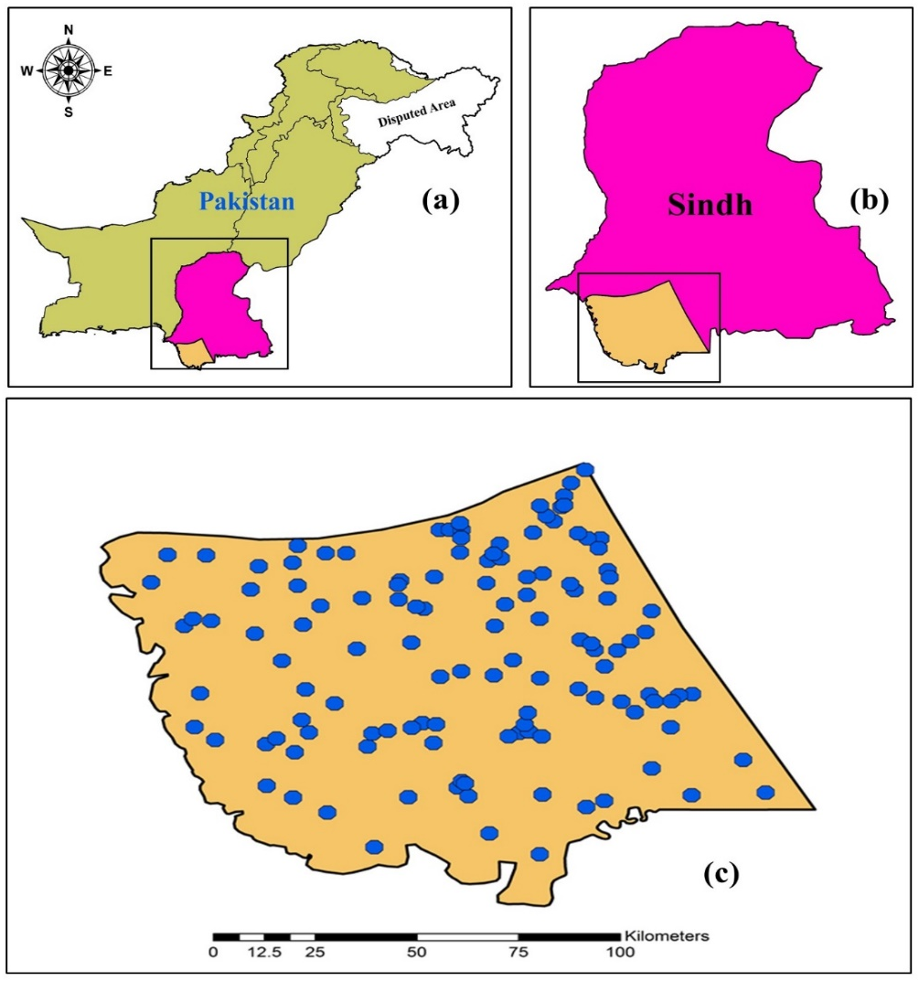
Fig. 1. GIS map of the Study Area and soil sampling locations
2.2 Soil Sampling
Georeferenced soil samples down to a depth of 60 cm (0-20, 20-40, and 40-60 cm) were collected randomly from various locations from the entire delta. A soil auger was used for extraction of soil samples; their locations were recorded using a portable handheld Garmin GPS [26]. Sampling locations are shown in Fig. 1(c). A total of 375 soil samples collected from 125 different locations which were analyzed for various physicochemical parameters viz. texture, dry density, EC, pH, and ESP.
2.3 Physicochemical Analysis of Soil samples
In the present study, a hydrometer method and USDA textural triangle were used for determination of textural classes of soil samples. The oven drying method was used to determine the dry density of the samples. The EC of soil saturation extract was determined at 25ºC using a portable Hanna Model-8733, German EC meter. The EDTA titration method was used for determination of calcium (Ca⁺²), and magnesium (Mg⁺²) cations in the soil. The soil pH was determined using a pH meter, and the sodium (Na⁺) concentrations were extracted with ammonium acetate solution (1 mol/L) and quantified according to Richards (1954) [27]. The results of these chemical parameters were used to determine the SAR (Sodium Absorption Ratio) and calculate the ESP using the respective empirical formulae [27].
2.4 Spatial Analysis Soil Salinity Mapping
Based on the results of the analysis, the interpolated maps of soil texture and most of the soil salinity indicators viz., EC, pH, and ESP were prepared through ArcGIS 10.5 using the spatial analysis Kriging and IDW approach. Based on soil salinity maps, the area of the IRD under salt-affected soils was determined.
3. Results and Discussions
3.1 Physicochemical analysis of Soil samples
The statistical summary of the results of physicochemical parameters of soil samples in the form of minimum, maximum, average, mode, standard deviation (STD), standard error of the mean (SE) and confidence error (CI) is depicted in Table 1.
Table 1 Data matrix of various physicochemical parameters of Soil samples
Parameter | Min. | Max. | Average | Mode | STD | SE | CI
Soil depth (0-20 cm)
Dry Density (g/cm³) | 1.20 | 1.40 | 1.30 | 1.28 | 0.05 | 0.004 | 0.02
EC (dS/m) | 0.45 | 55.2 | 14.28 | 11.76 | 13.98 | 1.25 | 2.45
pH | 6.8 | 11.42 | 7.93 | 7.5 | 0.58 | 0.05 | 0.10
ESP | 1.38 | 64.57 | 25.21 | 52.54 | 14.86 | 1.33 | 2.61
Soil depth (20-40 cm)
Dry Density | 1.19 | 1.44 | 1.27 | 1.27 | 0.04 | 0.004 | 0.01
EC | 0.56 | 48.0 | 11.52 | 13.78 | 11.86 | 1.06 | 2.08
pH | 7.1 | 9.2 | 7.99 | 7.5 | 0.43 | 0.03 | 0.07
ESP | 5.23 | 66.55 | 26.64 | 34.6 | 14.91 | 1.33 | 2.61
Soil depth (40-60 cm)
Dry Density | 1.17 | 1.40 | 1.26 | 1.27 | 0.04 | 0.003 | 0.01
EC | 0.66 | 41.8 | 9.57 | 2.36 | 9.98 | 0.89 | 1.75
pH | 7.2 | 9.21 | 8.01 | 7.7 | 0.43 | 0.038 | 0.07
ESP | 3.66 | 65.78 | 27.06 | 38.33 | 14.67 | 1.31 | 2.57

The dry density at 0-20 cm of soil depth varied from 1.20 to 1.40 g/cm³ with an average value of 1.30±0.02 g/cm³. Similarly, at the 20-40 cm depth, dry density varied from 1.19 to 1.44 g/cm³ with an average value of 1.27±0.01 g/cm³, while that at a depth of 40-60 cm it varied from 1.17 to 1.40 g/cm³ with an average value of 1.26±0.01 g/cm³.
Analysis for soil texture revealed that loam and clay loam soils are the dominant textural classes in the top soil layer in the Indus delta. About 37.8% of soil samples had loam, and 22.2% of soil samples had clay loam, 14.1% soil samples had clay, 8.9% had silty clay, 7.4% had silty clay loam, 5.9% had silty loam. While 2.2% had sandy clay loam, 0.74% had sandy loam, and 0.74% had a sandy texture. Thus, most of soils of delta have fine textural class. The coarse-textured sediment is deposited in upper regions while the river brings sediment dominated with fine particles at the tail end, i.e., Indus delta. FFC [28] reported suspended sediment in river Indus below Kotri on average contains 5.0% sand, 49.6% clay and 45.4% silt; hence the alluvial soils of the delta are dominated with the fine-textured soils. However, the lower soil layers, i.e., from 20 to 60 cm had almost similar soil texture distribution patterns.
The EC in 0-20 cm soil depth varied between 0.45 and 55.2 dS/m with an average of 14.28±2.45 dS/m. The EC values at 20-40 cm soil depth were between 0.56 to 48.8 dS/m with an average of 11.52±2.08 dS/m. According to the US division, as reported by Hammam and Mohamed [29], the soil is considered as saline, if its EC value exceeds 4 dS/m. In this regard, about 60.8% of the analyzed soil samples, the EC values exceeded 4 dS/m, indicating they were in the category of saline to highly saline soils. However, the EC in the soil samples collected at 40-60 cm of depth varied from 0.66 to 41.8 dS/m with a mean of 9.57±1.75 dS/m. About 56.8% of the soil samples at this depth had EC values greater than the FAO [30] guidelines. The soils having EC values of 0.7 dS/m or less are not stressful to most of the plants [31]. However, soil with an EC >0.7 dS/m causes problems for plants and many of the crop types. Generally, the soils having EC values >4 dS/m are considered as salt-affected soils. Hence, by this criterion, about 61.0% of the soil samples possessed EC values >4 dS/m. The spatial distribution of EC at various soil depths is portrayed in Fig. 2. From the Fig., it is evident that the areas of the IRD which are nearer to the coast are more affected by soil salinity compared to those which are far away from the coast. That is likely due to the impact of seawater intrusion in these areas.
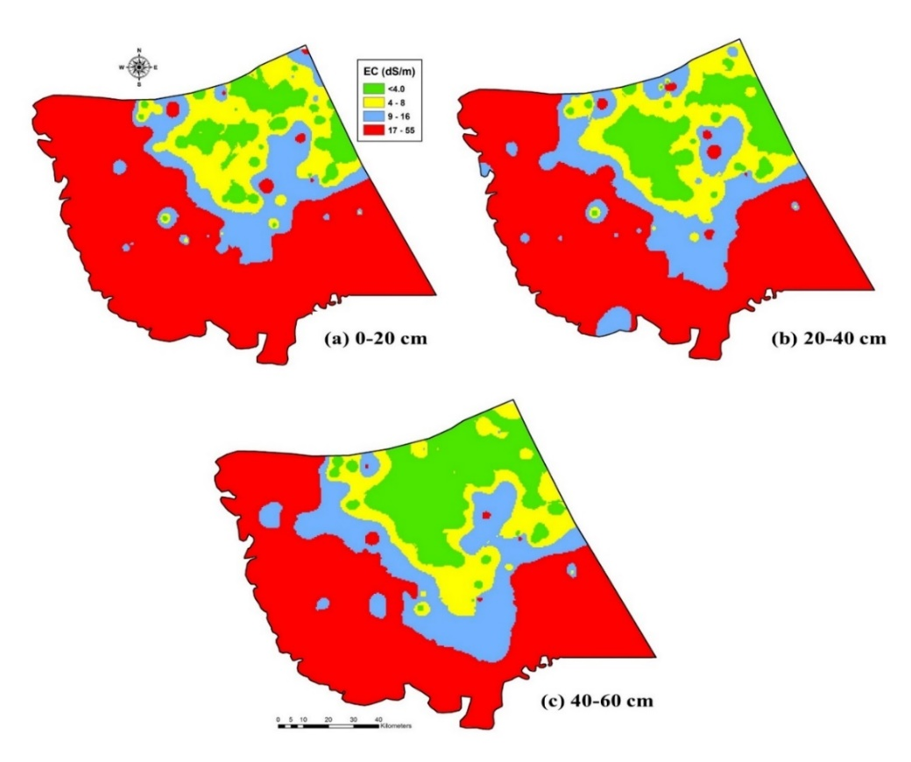
Fig. 2. Spatial distribution of EC in various soil depths
The hydrogen ion concentration (pH) in the top 0-20 cm soil layer varied from 6.8 to 11.42 with a mean value of 7.93±0.10, whereas, the pH of the 20-40 cm soil layer varied from 7.1 to 9.2 with a value of 9.99±0.07. Finally, the pH of the 40-60 cm soil layer ranged from 7.2 to 9.21 with an average of 8.01±0.07. A soil having a pH value of 7.0 is neutral, <7.0, to at least of 0.0, demonstrates expanding acidity. Generally, the soils having a pH >8.5 are considered as salt-affected soils. However, the soils with a pH >7.0, to the most extreme of 14.0, reflect increasing alkalinity. In the study area, most of the sampled soil (about 83.0%) had pH values within the range of 8.5.
The exchangeable sodium percentage (ESP) values in the top (0-20 cm) of soil depth in the study area ranged from 1.37 to 65.58 with an average of 25.21±2.6. At 20-40 cm of soil depth, the ESP values ranged from 5.23 to 66.55 with a mean of 26.64±2.61. Significantly, about 79.2% had ESP >15. The soils possessing ESP >15 are classified as salt-affected soils. In the study area, about 72.8% of soil samples had ESP >15. The ESP values at the 40-60 cm soil depth ranged from 3.66 to 65.78 with an average of 27.06±2.57. About 74.6% of the sampled soil had ESP values >15. Fig. 3 shows the spatial distribution of ESP in the soil samples gathered from 0-20, 20-40, and 40-60 cm depths. The maps portrayed that, the samples collected from the areas which are nearer to the coast possessed higher values of ESP. That likely is due to the seawater intrusion into the delta.
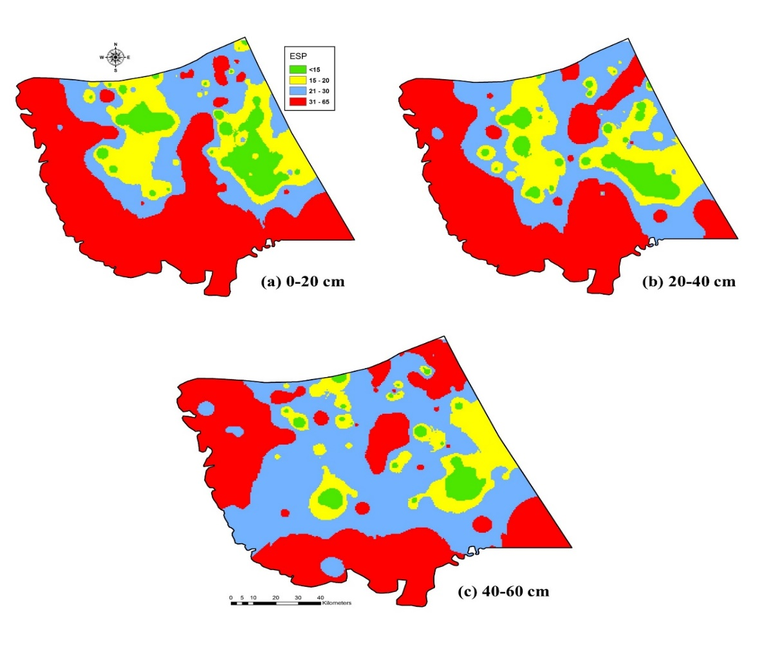
Fig. 3. Spatial distribution thematic maps for ESP at various soil depths of the IRD
Overall, the study revealed that EC of 57-66% of the soil samples collected from 0-60 cm were beyond the permissible level of 4 dS/m. Similarly, the pH of 14-18% of the soil samples had >8.5. While, about 73-79% of the analyzed soil samples possessed ESP values >15, which has been suggested by the FAO [30] for agricultural purposes.
3.2 Analysis of spatial distribution of soil salinity in the IRD
Based on ground truthing field data, spatial distribution thematic maps for various soil classes, i.e., normal, saline, sodic, and saline-sodic soils for all the three soil depths viz. 0-20 cm, 20-40 cm, and 40-60 cm were prepared (Fig. 4).
From maps, it is obvious that the soil salinity in the upper layer was higher than that in the subsoil, suggesting that the salts in the underlying layers transported upward and accumulated in the topsoil [9].
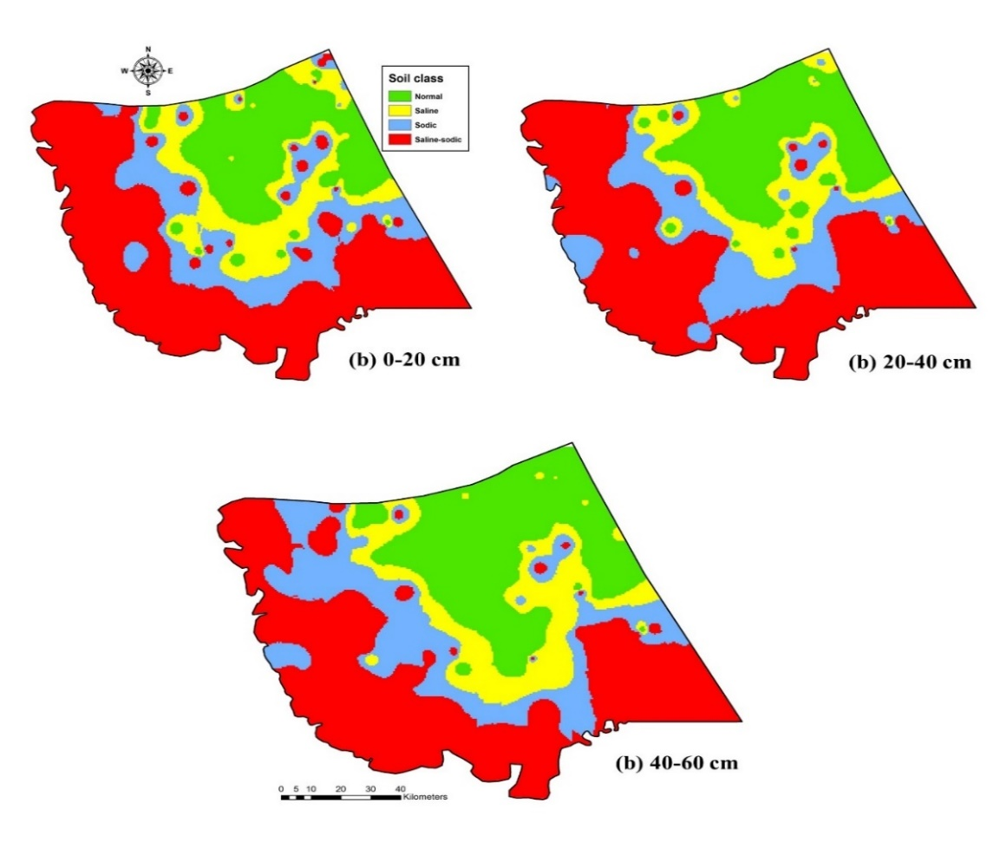
Fig. 4. Spatial distribution of soil classes to various depths
The spatial distribution soil salinity maps showed that >50% of the Indus delta soils were salt-affected. There was the strongest level of salinity in those samples which were taken from the coastal regions of the Arabian Sea, which most likely occur due to seawater intrusion [32].
4. Conclusions
Physicochemical analysis of soil samples collected from different depths of various locations within the Indus delta revealed that about 66.4%, 72.8% of the samples collected from top 0-20 cm soil layer had EC, and ESP values, respectively beyond the safe limits. Similarly, for soil samples collected from the 20-40 cm soil layer, 60.8%, and 72%, had EC and ESP values that exceeded the safe limits. While, for the deepest 40-60 cm soil layer, 56.8%, and 72.2% had EC and ESP values higher than the safe limits. On an average, the dry density in the soil samples varied from 1.26 to 1.30 g/cm³. Overall, spatial analysis of soil samples revealed that >50% of the IRD soils were affected by soil salinity. Reduction of the volume of freshwater flow in the Indus basin, low rainfall, seawater intrusion in the delta and various anthropogenic activities occurring along the coast are the most likely causes of degradation of soils in the IRD. The findings of the study are supportive of policymakers, farmers, and agriculturists in mitigating ecological degradation in the Indus delta and revival of soils of the delta.
Acknowledgements
We are extremely grateful to the U.S.-Pakistan Center for Advanced Studies in Water (U.S.-PCAS-W), Mehran UET, Jamshoro, Pakistan for funding the project entitled “Assessing the impact of Seawater Intrusion on Soil, Water, and Environment in the Indus River Delta using GIS and RS.” The project was funded by the U.S.-PCAS-W, under the applied research grants policy of the Centre. We are also thankful to Dr. Rick Bereit, Professor, The University of Utah, United States of America (USA) for his constructive comments and suggestions for improvement of the manuscript.
References
[1] Siyal, A.A., Siyal, A.G., and Abro, Z.A., (2002). Salt Affected Soil Their Identification and Reclamation, Pakistan Journal of Applied Science, 2(5) 537-540.
[2] Asfaw, E., Suryabhagavan, K.V., Argaw, M., (2016). Soil salinity modeling and mapping using remote sensing and GIS: The case of Wonji sugar cane irrigation farm, Ethiopia. Journal of the Saudi Society of Agricultural Sciences, http://dx.doi.org/10.1016/j.jssas.2016.05.003
[3] Nawar S, Buddenbaum H, Hill J. 2015. Estimation of soil salinity using three quantitative methods based on visible and near-infrared reflectance spectroscopy: a case study from Egypt. Arabian Journal of Geosciences 8:5127_5140.
[4] Wang, J., Ding, J., Abulimiti, A., and Cai, L. (2018). Quantitative estimation of soil salinity by means of different modeling methods and visible-near infrared (VIS_NIR) spectroscopy, Ebinur Lake Wetland, Northwest China, DOI 10.7717/peerj.4703
[5] Abuelgasim, A., and Ammad, R. (2018). Mapping Soil Salinity in Arid and Semi-Arid Regions Using Landsat 8 OLI Satellite Data, Remote Sensing Applications: Society and Environment, Available online 30 December 2018.
[6] Pankovaa, E.I, Gerasimovaa, M.I and Korolyuk, T.V. (2018). Salt-Affected Soils in Russian, American, and International Soil Classification Systems, Eurasian Soil Science, 2018, Vol. 51, No. 11, pp. 1297–1308.
[7] FAO (2007). Extent and causes of salt-affected soils in participating countries. AGL: Global network on integrated soil management for sustainable use of salt-affected soils, http://www.fao.org/ag/agl/agll/spush/topic2.htm
[8] Abbas A, Khan S (2007). Remote sensing-based modeling applications in land and water management: using remote sensing techniques for appraisal of irrigated soil salinity. International Congress on Modelling and Simulation (MODSIM), Modelling and Simulation Society of Australia and New Zealand Brighton 2632-2638.
[9] Yu, J., Li, Y., Han, G., Zhou, D., Fu, Y., Guan, B., Wang, G., Ning, K., Wu, H., and Wang, J. (2014). The spatial distribution characteristics of soil salinity in the coastal zone of Yellow River Delta, Environ Earth Sci., 72:589–599
[10] Ben Ahmed C, Magdich S, Ben Rouina B, Boukhris M, Ben Abdullah F (2012). Saline water irrigation effects on soil salinity distribution and some physiological responses of field-grown Chemlali olive. J Environ Manage 113:538–544.
[11] Alexakis D, Gotsis D, Giakoumakis S (2014). Evaluation of soil salinization in a Mediterranean site (Agoulinitsa District- West Greece). Arab J Geosci. doi:10.1007/s12517-0141279-0
[12] Allbed A, Kumar L, Aldakheel YY. (2014). Assessing soil salinity using soil salinity and vegetation indices derived from IKONOS high-spatial resolution imageries: applications in a date palm dominated region. Geoderma 230_231:1_8.
[13] Saleh, A.M. (2017). Evaluation of Different Soil Salinity Mapping Using Remote Sensing Indicators and Regression Techniques, Basrah, Iraq, Journal of American Science 2017;13(10) http://www.jofamericanscience.org
[14] Zare-Mehrjardi, M., Taghizadeh-Mehrjardi, R., Akbarzadeh, A. (2010). Evaluation of Geostatistical Techniques for Mapping Spatial Distribution of Soil PH, Salinity and Plant Cover Affected by Environmental Factors in Southern Iran, Notulae Scientia Biologicae, 2 (4) 2010, 92-103.
[15] Behera, S.K., Shukla, A.K., (2015). Spatial distribution of surface soil acidity, electrical conductivity, soil organic carbon content and exchangeable potassium, calcium and magnesium in some cropped acid soils of India. Land Degrad. Dev. 26, 71–79.
[16] Hosseini, E., D. Gallichand and D. Marcotte (1994). Theoretical and experimental performance of spatial interpolation methods for soil salinity analysis. Transactions of the ASAE 37:1799-1807. in irrigated agriculture using a remote sensing approach. Phys. Chem. Earth Parts A/B/C 55–57, 43–52.
[17] Mohammadi, J. (2000). Evaluation and maping of soil salinity hazard in Ramhormoz area (Khuzestan) using disjungtive kriging. Journal of Agricultural Research 25:45-57.
[18] Robinson, T. P. and G. Metternicht (2006). Testing the performance of spatial interpolation techniques for mapping soil properties. Computer and Electronics in Agriculture 50:97-108.
[19] Gorji, T., Tanik, A., Sertel, E., (2015). Soil Salinity Prediction, and Mapping Using Modern Technologies, Procedia Earth and Planetary Science, 15, 507-512.
[20] Kalhoro, N.A., He, Z., Xu, D., Xu, D., Faiz, M., Yafei, L.V., Sohoo Naimatullah, S., & Abdul Hadi, B. (2016) Vulnerability of the Indus River Delta of the North Arabian Sea, Pakistan, Global NEST Journal, 18(3), 599-610.
[21] Inam, A., Clift, P.D., Giosan, L., Tabrez, A.R., Tahir M., Rabbani M.M., and Danish M. (2007). The geographic, geological and oceanographic setting of the Indus River, Large Rivers: Geomorphology and management, edited by A Gupta, John Wiley & Sons, Ltd. 333-346.
[22] ADB (2005). Sindh Coastal and Inland Community Development Project, Interim Report, Vol. II, TA 4525-PAK, Asian Development Bank.
[23] Majeed, S., Zaman, S.B., Ali, I., & Ahmed, S. (2010). Situational Analysis of Sindh Coast Issues and Options Managing National Resources for Future Agriculture Research Briefings Volume 2 (11), 1-23.
[24] Alamgir, A., Khan, M. A., Schilling, J., Shaukat, S. S., & Shahab, S. (2016). Assessment of groundwater quality in the coastal area of Sindh province, Pakistan. Environmental Monitoring and Assessment, 188, 78-90.
[25] Bablani, S.A., & Soomro, S.A. (2006). Evaluation of seawater intrusions in left bank sediments of coastal district Thatta, Sindh, Pakistan. Paper presented at the 1st SWIM-SWICA Joint Saltwater Intrusion Conference, 24–29 September 2006
[26] Solangi, G.S., Siyal, A.A., Babar, M.M., & Siyal, P. (2018). Evaluation of surface water quality using the water quality index (WQI) and the synthetic pollution index (SPI): a case study of Indus Delta region of Pakistan. Desalination and Water Treatment, 118, 39-48.
[27] Pessoa, LGM, Maria BGDSF, Freire DS, Wilcox BP, Green CHM, Araujo RJTD and Filho JCDA (2016). Spectral reflectance characteristics of soils in northeastern Brazil as influenced by salinity levels. Environmental Monitoring and Assessment, 188:616.
[28] FFC (2005). Study on Water Escapages below Kotri Barrage to check seawater intrusion (Study-I). Final Report. Ministry of Water and Power. Government of Pakistan.
[29] Hammam, A.A., and Mohamed, E.S. (2018). Mapping soil salinity in the East Nile Delta using several methodological approaches of salinity assessment, The Egyptian Journal of Remote Sensing and Space Science, Available online 7 December 2018.
[30] FAO (1985). Guidelines, Land Evaluation for Irrigated Agriculture, Soil Bull. No 55, FAO, Rome, Italy.
[31] Kotuby-Amacher J, Koenig R, Kitchen B (1997). Salinity and plant tolerance. Utah Sate University Extension.
[32] Fourati HT, Bouaziz M, Benzina M, Bouaziz S (2015). Modeling of soil salinity within a semic-arid region using spectral analysis, Arab J Geosci. DOI 10.1007/s12517-015-2004-3.

