***EFFECTS OF BRICK AND AERATED CONCRETE INFILL WALLS ON BUILDINGS***

1st Hacer BİLİR ÖZHAN

Bursa Technical University,

Department of Civil Engineering

Bursa,TURKEY

[hacer.ozhan@btu.edu.tr](mailto:hacer.ozhan@btu.edu.tr)

3rd Caner BEKLEN

Çukurova University

Department of Civil Engineering

2nd İsmail H. ÇAĞATAY

Çukurova University

Department of Civil Engineering

Adana,TURKEY

hcagatay@cu.edu.tr

Adana,TURKEY

[cnr_beklen@hotmail.com](mailto:cnr_beklen@hotmail.com)

*Abstract*—It has already proved that infill walls had great impacts on behavior of frame systems especially under earthquake-like lateral loads. Infill walls generally considered as partition members between spaces in concrete frame systems. They are generally included into calculations as dead loads exerted on beams, but they have various impacts on behavior of frame-wall systems. Therefore, well-known behavior of infill walls will have positive contributions. In present study, a 10-story building was modeled with brick and aerated concrete infill walls. Infill walls were considered as weight and model and window and door spaces were taken into consideration in models. Infill walls were modeled with equivalent compression strut method. Changes in building rigidity, period, lateral displacement, base shear force and building behavior were investigated with the relevant analyses

Keywords-Infill wall, earthquake analysis, brick, aerated concrete, equivalent compression strut

Introduction

Together with increasing sheltering demands of people, construction industry is also continuously growing. However, lands available for construction are not increasing parallel to increasing population, thus high-rise buildings are constructed to benefit from the available lands. In this sense, economy and utilization of concrete frame systems have become significant issues of construction industry. Generally, light-weight materials are preferred in such frame systems especially for heat, noise and similar insulations and partition walls are constructed also with these materials to facilitate the utility of building space. Infill walls have significant effects on bearing-system of the building under lateral loads; therefore, behavior of these walls under lateral loads like earthquake loads should be well elucidated. Negative impacts of such walls are generally attributed to diverse range of materials, diversity in strength of these materials and insufficient inspections of present implementations. In practice, these walls are reflected in calculations as the members increasing only the dead loads of the building and their load-bearing behaviors are generally neglected. Observations and investigations on earthquake damages of the buildings revealed that although infill walls were not considered in calculations made for earthquakes, they resisted to lateral earthquake loads like a shear wall wall until the time of failure. Post-failure behavior of these walls cannot be estimated accurately and they are considered as if they did not exist in calculations. Then, great damages are experienced in practice. Literature on infill walls revealed that infill walls had significant contributions to rigidity, load-bearing capacity, period and damping-like dynamic attributes of the buildings. The structure together with all constructional members behaves like a composite material. Therefore, behavior of each and every single member constituting the structure should be known. In present study, a ten-story building was modeled to investigate how effective the infill walls in increasing building resistance to vertical and especially to lateral loads. Bricks and aerated concrete were used in building infill walls. In analysis calculations, effects of infill walls with two different materials were investigated.

METHODOLOGY

Building Infill Wall

Corresponding author: Hacer BİLİR ÖZHAN

There are several studies in literature about the behaviors of frame systems with/without partition walls under earthquake and similar lateral loads. In a previous study investigating building behavior under lateral loads, experiments were conducted to determine the behavior infill walls under lateral loads and it was reported that the concrete frame with infill walls had greater load-bearing capacity than the frames without infill walls and infill walls significantly improved building elasticity and rigidity behaviors. [1]. Infill walls are not always formed in fully-filled fashion. There may be empty spaces on them left for different purposes. In another study, in cases where infill wall was created as macro-void and low strength, the frame system with infill wall provided at least 40% greater contribution to lateral load-bearing capacity as compared to frame system without an infill wall. [2]. Similarly, a soft-story concrete building and a concrete building without infill walls exhibited similar behaviors with regard to lateral load bearing capacity. [3]. In Turkey, ground floors are generally used for various purposes other than housing. Ground floor projects are thus generally altered (columns are cut, existing walls are removed and etc by the users. Therefore, partition walls generally do not exist in ground floors. Then, the upper floors behave more rigid because of the partition walls as compared to ground floors. Such a case resulted in concentrated energy consumption at the ground floors. A soft-story is formed in such buildings and destructive damages and failures are experienced in this weaker floor of the building as compared to the other floors. In other cases, damages are generated over the columns of these floors without infill walls. Since the earthquake energy is confronted in this floor, rigidity of the columns and shear walls of this floor should be improved as to bear inter-floor displacements. If the walls are constructed short and connected to frames, then the columns of the main frame cannot bend in between two stories they connected under lateral forces of an earthquake because of the rigidity of the walls along their own planes. Then a soft-story is formed. In this case, columns are forced to bend over the section with the empty height left over the upper sections of the walls. Then quite greater shear forces are generated over this section of the columns. [4]. Long windows extending along the both sides of the walls preferred in factory-like buildings generate a short-column effect and reduce effective length of the column. Experimental works on frames with infill walls revealed that door and window spaces should be avoided on these members and thus building rigidity should be increased to reduce potential damages on buildings. [5], [6] Confinement of stirrup should be increased to bear resultant shear force.

Brick as infill wall material

Brick is one of the most commonly used and preferred materials for infill walls of concrete structures. Since the use of two different materials in infill walls was compared in this study, horizontally perforated bricks with greater hallow ratios were used since they have low compression strength Specifications for horizontally perforated bricks are provided in Table 1. While modeling infill walls, 13.5 horizontally perforated bricks were used in exterior walls and 8.5 horizontally perforated bricks were used in interior walls.

Specifications of horizontally perforated bricks with different dimensions

|  |  |  |
| --- | --- | --- |
| Specification | 8.5 Horizontally perforated bricks | 13.5 Horizontally perforated bricks |
|  |  |
| Height x Width x Length  (cm) | 8.5 x 19 x 19 | 13.5 x 19 x 19 |
| Mean Compressive Strength  (MPa) | 4 | 5.2 |
| Weight of single brick  (kg) | 2 | 3 |
| Number of bricks per m2 | 25 | 25 or 33 |

G2-class aerated concrete was the other material used as infill wall material. This material is generally used as exterior and interior infill wall material of concrete frame structures or used as load-bearing exterior and interior wall material of masonry structures. They are composed of 70-80% less, circular and homogeneous hallows and resistant to earthquake and fires. Specifications for G2-class aerated concrete are provided in Table 2.

Specifications for aerated concrete with different dimensions

|  |  |  |
| --- | --- | --- |
| Specification | For interior walls | For exterior walls |
|  |  |
| Length x Height x Width  (cm) | 60 x 25 x 8.5 | 60 x 25 x 19 |
| Mean Compressive Strength (MPa) | 2.5 | 2.5 |
| Weight of Single Aerated concrete (kg) | 5.1 | 12 |
| Number of aerated concrete per m2 | 6.66 | 6.66 |

Modulus of Elasticity

Infill wall modulus of elasticity significantly influence wall rigidity of frame-wall systems. Infill walls exhibit complex behaviors since modulus elasticity values in different directions (horizontal, vertical, diagonal) are different. There are several studies in literature indicating significant effects of compressive strength of the material, height, compressive strength of mortar layer on modulus elasticity. [7] It was also indicated in previous studies that modulus of elasticity of infill walls were different for plastered and unplastered walls and also varied with the thickness of the plaster layer. also alters modulus of elasticity. In this sense, modulus of elasticity values of brick walls used in different studies are provided in Table 3. In this table, Ew and Ec respectively express the modulus of elasticity of the wall and the concrete under compression.

Specifications for aerated concrete with different dimensions

|  |  |  |  |
| --- | --- | --- | --- |
| Literature | Ew  (MPa) | Ec (MPa) | Ed / Ec |
| [8] | 5200 | 30000 | 1/6 |
| [9] | 1240 | 30000 | 1/24 |
| [10] | 2850 | 28500 | 1/10 |
| [11] | 6000 | 12000 | 1/2 |
| [12] | 700 | 25310 | 1/36 |
| [13] | 17000 | 28500 | 1/1.7 |
| [14] | 3000 | 32000 | 1/10 |
| [15] | 1000 | - | - |

In a previous study carried to determine aerated concrete wall modulus of elasticity values [16], modulus of elasticity of a wall constructed with G2-class aerated concrete and without plaster was reported as 1500 MPa. Modulus of elasticity of a plastered wall was reported as 2091 MPa, unit weight was reported as 400 kg/m3 and compressive strength was reported as 2.5 MPa. In a similar study [17], masonry aerated concrete blocks were cut into 10 x 10 x 10 cm cubes and 10 x 10 x 40 cm prisms and their modulus of elasticity and Poisson ratios were experimentally determined. Resultant values were summarized in Table 4.

Physical attributes of aerated concrete wall

|  |  |  |  |  |
| --- | --- | --- | --- | --- |
| Specific Gravity  (N/m3) | Mean Cube Strength  (MPa) | Mean Prismatic Strength  (MPa) | Mean initial modulus of elasticity  (MPa) | Mean Poisson ratio |
| 7500-8000 | 4.90 | 3.32 | 1620 | 0.21 |
| 9000 | 4.60 | 3.08 | 1570 | 0.20 |
| 8000-8500 | 3.60 | 2.64 | 1490 | 0.19 |

In another study [18], modulus of elasticity of aerated concrete of a wall panel was identified as 1750 MPa. Specifications of Turkish Aerated concrete Producers Association for aerated concrete of wall blocks are provided in Table 5. [2].

Aerated concrete wall blocks

|  |  |  |  |  |  |  |  |
| --- | --- | --- | --- | --- | --- | --- | --- |
| Material Strength Class | G2 | | G3 | | G4 | | Unit |
| Mean compressive strength | 2.5 | | 3.5 | | 5.0 | | MPa |
| Modulus of elasticity | 1250 | 1750 | | 2250 | | 2750 | MPa |

Equivalent Virtual Bar Model

Previous studies conducted to determine and elucidate the linear behaviors of infill walls [19], [20] revealed diagonal cracks at the center of modeled panel, voids between the frame and infill at opposite unloaded corners of the model and a full contact at the other two loaded diagonal corners. To reflect such behaviors on actual infill walls and to facilitate the analysis of infill wall frame systems, infill walls were placed as equivalent compression struts (Figure 1).

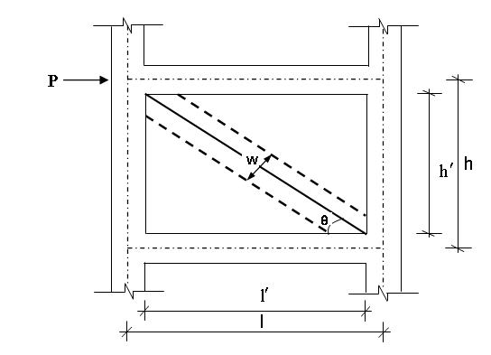

1. Representation of infill wall analysis model

The compressive load-bearing region was represented with an equivalent virtual bar in static analysis of frame systems under external forces (Figure 2).

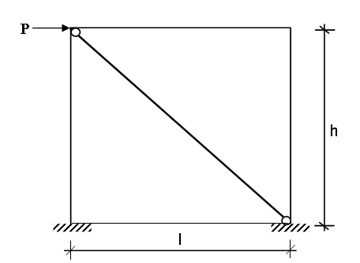

1. Representation of infill wall frames with two end- hinged equivalent virtual diagonal bar

Different researchers used different assumptions in calculating the thickness of equivalent diagonal struts. [19] and [20], proposed the Equations (1) and (2) for [strut](https://www.sciencedirect.com/topics/engineering/struts) width representing the infill wall:

w =0.175 (λ h)-0.4 (1)

 (2)

The θ value used in Equation (2) is calculated with the aid of Equation (3):

θ = tan-1 (/ ) (3)

Where;

w: width of equivalent virtual compression strut, λ: Rigidity parameter of the infill and frame, h: Floor height, l: Frame span, : infill wall height, : infill wall width, Em: Modulus of elasticity of equivalent virtual compression strut, t: infill wall thickness, θ: Angles of equivalent virtual compression strut from the horizontal plane, Ec: Frame modulus of elasticity, Ic: Column moment of intertie

Partially İnfilled Frames

Infill walls are constructed in full or they may have window and door spaces. In such cases, equivalent compression strut width is multiplied with a reduction factor to include loss of strength due to these void spaces into calculations [21].

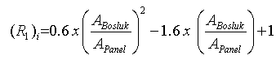 Wreduction = w (R1)i (R2)i  (4)

(5)

(5k

Agap:Total area of void spaces over the infill wall

Apanel:Full area of infill wall without voids

(R1)i: Expression of reduction factor for infill walls with void spaces

(R2)r: Expression of reduction factor for existing infill damages.

In cases where infill walls have window and door spaces, the reduction factor R1 is applied in calculations made for the width of equivalent compression strut. In cases where there aren’t any damages on infill walls, then R2 is considered as 1. In cases where there are heavy damages, R2 can be taken as 0 since the wall will have slight contributions to building rigidity due to breakouts between the frame and the infill wall. In such cases, wall will contribute to only the weight of the building and will not have any contributions to lateral rigidity.

Building Model

A building was modeled with two different infill wall materials to investigate the effects of infill walls on structural irregularities. Total floor height (HN) was 15 m and elasticity level was high. Earthquake analysis of a regular structure was performed with equivalent earthquake load method.

Building information

|  |  |
| --- | --- |
| Building Information | |
| Slab | 12 cm |
| Interior wall thickness (Brick and Aerated concrete) | 10 cm |
| Exterior wall thickness (Brick and Aerated concrete) | 20 cm |
| Beam Dimensions | 25 x 50 cm |
| Column Dimensions | 40x40 cm |
| Concrete Class | C30 |
| Concrete Modulus of Elasticity (Ec) | 32000 MPa |
| Brick Wall Modulus of Elasticity (Ew) | 1000 Mpa |
| Aerated concrete Wall Modulus of Elasticity (Ew) | 2091 Mpa |
| Number of Floors | 10 |
| Bearing System Type | R.C. Frame |
| Floor Height | 3 m |
| Earthquake Zone | 1 |
| Effective Ground Acceleration Coefficient | 0,4 |
| Local Ground Class | Z3 |
| Spectrum Characteristic Periods | TA=0.15sn  TB=0,60 sn |

Building axles along x-axis are A, B, C, D, E and F and axle spacing was 5 m (Figure 3). The axles along y-axis are 1, 2, 3 and 4 and axle spacing was 4 m, 2 m and 4 m. Except for the window in the hall, size of all windows was 150 x 130 cm and door size was 90 x 220 cm. Size of window at hall was 100 x 200 cm. The building was considered as separated from a-axle with a joint to separate shear wall effect from the building, in this way, effects of infill wall on building were analyzed

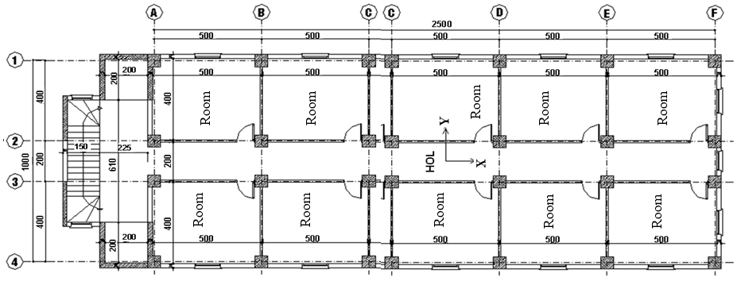

1. Building model

The abbreviations for the model were provided below;

BEF: Empty frame modeled though taking brick wall only as weight

BWF: The frame with brick wall considered as weight and model

GEF: Empty frame modeled though taking aerated concrete wall only as weight

GWF: The frame with aerated concrete wall considered as weight and model

Normal floor weight (N), roof-floor weight (R) and total building weight at an incidence of earthquake (W) are provided in Table 7.

Building floor weights

|  |  |  |  |  |
| --- | --- | --- | --- | --- |
| Floor | wi (t) | | | |
| BEF | BWF | GEF | GWF |
| N | 287.25 | 287.25 | 252.85 | 252.85 |
| R | 228.19 | 228.19 | 217.22 | 217.22 |
| W | 2813.44 | 2813.44 | 2492.87 | 2492.87 |

Building total weight was reduced by 11.36% with the use of aerated concrete wall instead of brick wall. The first natural vibration period of 10-story building along y-axis was calculated with the aid of Rayleigh ratio. Period values are provided in Table 8.

Period values of the building

|  |  |  |  |
| --- | --- | --- | --- |
| Period (s) | | | |
| BEF | BWF | GEF | GWF |
| 1.38 | 1.17 | 1.28 | 1.01 |

Period values decreased by 7.25% with decreasing building weight. Weight and modulus of elasticity together decreased period values by 13.68%. Period values decreased by 15.22% with the modeling of brick wall and 21.09% with the modeling of aerated concrete wall (Table 9).

% reductions in building period values

|  |  |  |  |
| --- | --- | --- | --- |
| BWF/BEF | GWF/GEF | GEF/BEF | GWF/BWF |
| 15.22 | 21.09 | 7.25 | 13.68 |

Total equivalent earthquake load of 10-story building along y-axis (Base Shear Force) (Vt) was calculated and provided in Table 10.

Base shear force values of the building

|  |  |  |  |
| --- | --- | --- | --- |
| BEF | BWF | GEF | GWF |
| 183.00 | 208.07 | 170.36 | 192.77 |

Base shear force values decreased by 6.91% with decreasing building weight. Weight and modulus of elasticity together reduced base shear force values by 7.35%. Base shear force values increased by 13.70% with the modeling of brick wall and by 13.155 with the modeling of aerated concrete wall (Table 11).

% changes in building base shear forces

|  |  |  |  |
| --- | --- | --- | --- |
| BWF/BEF | GWF/GEF | GEF/BEF | GWF/BWF |
| (+)13.70 | (+)13.15 | 6.91 | 7.35 |

Equivalent floor earthquake loads were affected on displaced center of gravity considering +5% additional eccentricity at floor alignments (ey=0.5). Eccentricity-induced displacement values for the 10th floor of the building are provided in Table 12. Reductions in displacement values were also calculated and provided in Table 13.

|  |  |  |  |
| --- | --- | --- | --- |
| Frames | (di)min (m) | (di)max (m) | |
|  |  | |
| BEF | 0.0410 | | 0.0579 |
| BWF | 0.0343 | | 0.0470 |
| GEF | 0.0382 | | 0.0539 |
| GWF | 0.0235 | | 0.0318 |

Displacement values of 10th floor

% reductions in building displacement values

|  |  |  |  |  |  |  |  |  |
| --- | --- | --- | --- | --- | --- | --- | --- | --- |
| Floor | BWF/BEF | | GWF/GEF | | GEF/BEF | | GWF/BWF | |
| min. | max. | min. | max. | min. | max. | min. | max. |
| 10 | 16.37 | 18.80 | 38.49 | 41.07 | 6.87 | 6.88 | 31.50 | 32.42 |
| 9 | 16.75 | 19.06 | 39.03 | 41.46 | 6.87 | 6.88 | 31.79 | 32.65 |
| 8 | 17.07 | 19.24 | 39.51 | 41.88 | 6.89 | 6.90 | 32.09 | 32.99 |
| 7 | 17.32 | 19.35 | 39.95 | 41.96 | 6.86 | 6.89 | 32.36 | 32.99 |
| 6 | 17.58 | ***19.42*** | 40.29 | 42.11 | 6.90 | 6.90 | 32.55 | 33.12 |
| 5 | ***17.72*** | 19.37 | 40.60 | ***42.16*** | 6.88 | ***6.91*** | 32.78 | 33.21 |
| 4 | 17.71 | 19.17 | ***40.77*** | 42.05 | 6.92 | 6.90 | ***32.99*** | ***33.26*** |
| 3 | 17.50 | 18.67 | 40.63 | 41.65 | ***6.96*** | 6.87 | 33.04 | 33.19 |
| 2 | 16.57 | 17.50 | 39.93 | 40.52 | 6.90 | 6.90 | 32.97 | 32.88 |
| 1 | 13.73 | 14.23 | 36.94 | 37.03 | 6.72 | 6.82 | 31.82 | 31.59 |

Maximum displacement graphs of 10-story building for different column sizes were drawn for all floors. Displacements increased with increasing number of floors. While BEF had the top position, GWF had the bottom position in graphs. BWF graph was positioned below GEF graph (Figure 6).

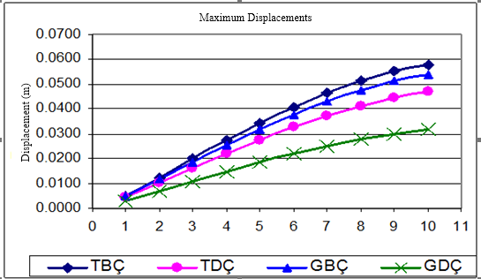

1. Maximum deflection graphs of the building

Earthquake analysis for all frame systems of the building revealed that torsion irregularity, rigidity irregularity, relative floor displacement and second-order indicator values were below the limit values specified in [22].

CONCLUSION AND DISCUSSION

In previous experimental studies, brick wall modulus of elasticity values were reported as between 1000 MPa – 4272 MPa and the a value of 1000 MPa taken based on concrete class for hallow bricks used in construction of a hotel was found to be suitable [14]. With the use of aerated concrete instead of brick in infill walls, building total weight decreased by 11.36%, period values decreased by 7.25%, base shear force values decreased by 6.91% and displacements decreased by between 6.72-6.96%. Weight and modulus of elasticity together reduced period values by 13.68%, shear force values by 7.35% and displacements by between 31.50-33.26%. With the modeling of brick wall, period values decreased by 15.22%, shear force values increased by 13.70% and displacements decreased by between 13.73-19.42%. With the modeling of aerated concrete, period values decreased by 21.09%, shear force values increased by 13.15% and displacements decreased by between 36.94-42.16%.

Eventually, in Turkey where frequent earthquakes and regrettably heavy destructions are experienced, any concessions should not be made on quality and rigidity of the buildings. Therefore, behaviors of any single constructional member should be well-known and calculations should be made accordingly. Previous literatures and present analyses revealed that infill walls had great contributions to building behavior under lateral loadings like earthquakes and negligence will bring about various negative outcomes. It was recommended based on present findings that these existing structural members should definitely be included into calculations to improve positive impacts of infill walls on structure strength, elasticity and rigidity.

Acknowledgment

This study was supported by Scientific Research Projects Department of Çukurova University (Project No: MMF2008YL3).

REFERENCES

1. Govindan, P., Lakshmipaty M., Santhakumar, A. R., Ductility of Infilled Frames, A.C.I. Journal, pp. 567-576, 1986
2. Vintzeleou,E. Infilling of Reinforced Concrete Frames as a Strengthening Intervention. Seminar on the Assesment and Redesign of Reinforced Concrete Structures,İzmir,1989.
3. Negro P. And Verzeletti G., Effect of Infills on the Global Behaviour of R/C Frames:Energy Considerations from Pseudo-synamic Tests. Earthquake Engineering and Structural Dynamics, Vol.25, No.7, pp. 753-773 ,1996.
4. Çağatay, İ. H.,2007,Binalarda Kisa Kolona Etki Eden Parametrelerin İncelenmesi, Altıncı Ulusal Deprem Muhendisliği Konferansı, 16-20 İstanbul, 2007,
5. Zarnic,R. and Tomasevic.M., Modelling of Response of Masonry Infilled Frame. 10. Th Europen Conference on Earthquake Engineering, Rotterdam.,1995.
6. Koçak,A., Depreme Dayanıklı Yapı Tasarımı Ders Notları,Yıldız Teknik Üniversitesi. 1998,
7. Bilir Özhan. H, Çağatay. İ. H, Mechanical behavior of brick masonry panels under uniaxial compression, Journal of Mechanics of Materials and Structures, vol. 9, no. 4, pp. 385–395, Jan. 2014.
8. Demirel, İ.O., Canbay,E., Binici, B., Yakut, A., Eryurtlu., Z., Gazbeton Dolgulu Betonarme Çerçevelerin Deprem Performansi Üzerine Deneysel Çalişma, 3. Türkiye Deprem Mühendisliği ve Sismoloji Konferansı. İzmir, 2015.
9. Aydoğdu, İ., Dolgu Duvarlı Çerçevelerin Davranışı, Yüksek Lisans Tezi, Yıldız Teknik Üniversitesi, 29s, 1995.
10. Yalçın, E., , Dolgu Duvarları ve Konumlarının Çok Katlı Betonarme Yapıların Deprem Kuvvetleri Altındaki Davranışına Etkileri. Yüksek Lisans Tezi, İTÜ, 67s,1999.
11. Çağatay, İ. H. ve Güzeldağ, S., Yeni Deprem Yönetmeliği (TDY-98) SAP2000N Uygulamaları, Birsen Yayınevi, İstanbul, 213s , 2002
12. Öktem, O., Betonarme Çerçeve Sistemlerinin Lineer Olmayan Hesabı ve Dolgu Duvarların Modellenmesi, Yüksek Lisans Tezi, İTÜ, 98s. 2003.
13. Dündar, E., Çok Katlı Betonarme Yapılarda Bölme Duvarlarının Deprem Davranışına Etkisi, Yüksek Lisan Tezi, Çukurova Üniversitesi, 169s. 2007.
14. Budak, A., Dolgu Duvarlı Çerçevelerin Sonlu Elemanlar Yöntemi İle Malzeme Bakımından Doğrusal Olmayan Hesabı, Doktora Tezi, Karadeniz Teknik Üniversitesi, 125s. 1997.
15. Dönmez, S., Deprem Etkisinde Betonarme Binalarda Hasarın Oluşmasında Dolgu Duvarların Modellenmesi ve Taşıyıcı Sisteme Katkısı. Yüksek Lisans Tezi, İTÜ, 75s, 2006.
16. Yücesan, B., Betonarme Çerçevelerin Güçlendirilmesinde Yüksek Dayanımlı Tuğla Duvarlar, Yüksek Lisans Tezi, İTÜ, 99s. 2005.
17. Karaduman, A., Dolgu Duvarlı Çerçevelerin Yatay Yükler Altındaki Davranışları Üzerine Deneysel Bir Çalışma, Mühendislik Fakültesi Mühendislik Bilimleri Dergisi, Pamukkale Üniversitesi, 11, 3, 2005, 345-349
18. Babayev Z., Eyyubov C., Murat İ. And Askerov C., , Kireç Taşıyla Yapılmış Taşıyıcı Duvarların Düşey ve Yatay Yüklerin Etkisi Altındaki Davranışının Araştırılması. ACE Beşinci Uluslararası İnşaat Mühendisliğinde Gelişmeler Kongresi, İTÜ, İstanbul, 2002.
19. Sesigür H., Çelik O. C. ve Çılı F., Deprem Riski Düşük Bölgelerde Orta Yükseklikteki Donatılı Gazbeton Binaların Uygulanabilirliği. Altıncı Ulusal Deprem Mühendisliği Konferansı, İstanbul, 2007.
20. Smith, B. S. and Carter, C. A Method of Anlaysis for Infilled Frames, Institution of Civil Engineers (ice), Vol. 44, pp. 31-48, 1969.
21. Mainstone, R.J. Suplementary Note on the Stifness and Strengths of Infilled Frames, Building Research Station, UK, Current Paper 13/74, 1974.
22. Çağlayan, E., Betonarme Çerçevelerin Yatay Yüklere Göre Analizinde Dolgu Duvar Etkisinin İncelenmesi,Yüksek Lisans Tezi,Celal Bayar Ünv. Fen Bilimleri Enst. 2006.
23. Türk Deprem Yönetmeliği, Deprem Bölgelerinde Yapılacak Yapılar Hakkında Yönetmelik, 6 Mart 2007 tarih ve 26454 sayılı Resmî Gazete, 2007.