Development and experimental Investigation on delay time consistency of modified Si/ PbO/Pb₃O₄/FG pyrotechnic delay composition

Abdul Qadeer Malik

Azizullah Khan
School of Chemical and Material Engineering
National University of Sciences and Technology Islamabad, Pakistan
aziz.phd@scme.nust.edu.pk

School of Chemical and Material Engineering
National University of Sciences and Technology Islamabad, Pakistan
aqmalik@scme.nust.edu.pk

Zulfiqar H. Lodhi
School of Chemical and Material Engineering
National University of Sciences and Technology
Islamabad, Pakistan

Abstract— Experimental Investigation was carried out on the delay time consistency of modified Si/PbO/Pb₃O₄/FG pyrotechnic delay composition in a delay tube. Where Si is a fuel, PbO/ Pb₃O₄ are oxidizers and Fish Glue is a binder. In the reported research work two parameters ingredients mixing and loading pressure were studied. Results reveal that homogenous mixing of the delay composition is a very critical parameter for controlling the time consistency of pyrotechnic delay composition. The delay time accuracy was improved from 25% to about 7.42 % by ensuring homogenous mixing of the ingredients. Results also show that loading pressure ranged from 30000 to 65000 psi did not much effect the delay time of this pyrotechnic delay composition and hence the burning rate.

Keywords- Delay Composition; Loading pressure; Time consistency; Delay time; Burning rate
- Introduction
Pyrotechnic is a mixture of Fuel, Oxidizer and Binder. Pyrotechnic is a general term for a mixture that burns at a selected, reproducible rate, providing a predetermined time delay between ignition and the delivery of main effects [1, 2]. The modern practice of requiring pyrotechnic delays to function very accurately has led to an intensive research into the mechanism and control of combustion both of gas producing and gasless pyrotechnic mixtures. Moreover, it has narrowed the field of investigation to the relatively few combustible materials that can be considered suitable for this kind of precise applications. Pyrotechnic compositions are mixture of ingredients, which usually are not themselves explosive, and are designed to burn but not to detonate. Typical burning rate of pyrotechnics can vary from below 1 mm/sec to over 1000 mm/sec [3]. Like other applications one of the most important applications is that these are used as delay devices in sophisticated missile systems to provide required delay time before performing certain functions and to detonate the warhead after predetermined delay time. End result of any weapon or missiles system is greatly dependent on the accurate and consistent delay time. Propagation or burning of pyrotechnic delay device is dependent on number of factors such as confinement, particles size, percentage of fuels, diameter, thickness of delay body, conductivity of delay body, geometry of the delay body, nature and ratio of ingredients, initial temperature, ambient temperature, ambient pressure, consolidation pressure, moisture, terminal charge, ignition composition, delay body material, storage condition , charge increment, additives, intimate contacts of ingredients etc.[4-9 ]. Repeatability and accuracy of any pyrotechnic delay device depends on design and development of a pyrotechnic delay composition which in turn depends on mixing and particle sizes of ingredients, grain size of delay composition, type, internal diameter and length of the delay tube. Delay time repeatability has been a problem in pyrotechnic delay compositions. The main problem in pyrotechnic delay compositions is the accuracy that ranges between ±10 % to ± 20 % of the average value over the normally military operating temperature of -40 C° to + 60 C° [11]. In some pyrotechnic the time delay increased up to 25% from mean at low temperature of -54 C° [12-14].
The main objectives of this research were:
To develop a modified fast pyrotechnic delay composition comprising Silicon as fuel, PbO/Pb₃O₄ are oxidizers and Fish Glue as a binder.
To experimentally investigate the effect of mixing of ingredients and Loading pressure on delay time consistency of this pyrotechnic delay composition in a pyrotechnic delay device.

- Experimental Part
2.1 Materials

Analytical grade Fuel Silicon Powder and Oxidizers Lead (II) Oxide (PbO) and Lead Oxide Pb₃O₄ purchased from Sigma Aldrich Company and commercial grade Fish Glue binder were used during this research work. The purity of these ingredients is ≥99%. The particle sizes of Silicon (Si), Lead (II) Oxide (PbO) and Lead Oxide Pb₃O₄ were ≤44 µm, 1~2 µm and < 10 µm respectively. Distilled was used for preparation binder solution.

2.2 Preparation of Pyrotechnic Delay Composition
Two methods were used for the preparation of the pyrotechnic delay composition.

2.2.1 (3-D) Automatic Tumbler Mixing Machine
The individual chemicals (fuels and oxidizer) were dried in heating oven at 80 C° for two hours to remove the moisture. The required quantities of the different ingredients (fuel,
Oxidant and binder) were weighed according to the required percentages and blended thoroughly mixed the ingredients in the (3-D) automatic Tumbler Mixing Machine for 3 hours. A binder solution of 0.3 % Fish Glue was prepared in distilled water. Mixed the binder solution in the already mixed composition to form the homogenous paste by using the spatula in agate container. Then semi dried the composition (paste) in the Drying oven at 80 C°. Semi dried composition was broken in to lumps by spatula in an agate container carefully. Passed the composition carefully through -212 mesh sieves to get grain size of ≤ 65 µm. Then dried the grains for four hours at 80 C° to remove the water/moisture. Stored the finished composition in container and placed it in desiccator.

2.2.2 Manual Mixing Mortar and Pestle:
The individual chemicals (fuels and oxidizer) were dried in heating oven at 80 C° for two hours to remove the moisture. Weight the chemicals according to the required percentages. Prepared small batches of 5 gram and mixed the chemicals in Mortar and pestle for 30 minute to get homogenous mixture. Then a binder solution of 0.3 % Fish Glue was prepared in distilled water. Mixed the binder solution in the already mixed composition to form the homogenous paste by using the spatula in agate container. Then semi dried the composition (paste) in the Drying oven at 80 C°. The semi dried composition was broken into lumps by spatula in an agate container carefully. Passed the composition carefully through -212 mesh sieves by using Haver test shaker EML 200-89 digital to get grain size of ≤ 65 µm. [15, 16]. Dried the grains for eight hours at 80 C° to remove the water/moisture. Stored the finished composition in container and placed it in desiccator. The composition was then kept in the desiccator for 24 Hours to become stable.

2.2.3 Safety during manual preparation of delay composition:

This delay composition is very sensitive to friction, especially during manual mixing/grinding of the ingredients in the Mortar and Pestle and at the time of grain formation when the composition is passed through a particular sieve to get the desired grain size. The following safety precautions are very essential to avoid injuries to the operators
- Ensue the exposure of minimum operators to the hazards of pyrotechnic mixture during processing steps
- As this is manual process so the quantity of pyrotechnic composition for each batch was kept 05 grams to minimize the risks.
- Use specially designed Mortar and Pestle
- Use bullet proof screen while dry mixing the composition
- Use goggle and gloves while handling and preparing the composition

2.2.4 Filling of delay body:
Stainless steel delay elements were made by drilling 0.157 inch diameter holes through Stainless Steel rods. The length of the tubes were kept 0.787 inch. The finished composition was then loaded into stainless steel delay tube in five equal increments. Each increment was accurately weighted separately and pressed in a delay tube one by one. The surface of the delay column was kept flushed with the end of the delay tube. Excess delay composition was removed by sliding the end of the delay tube. A hydraulic press machine installed with a calibrated gauge was used to consolidate the delay composition in the delay tube. At compaction loads from 10,000 to 65,000 psi, the pyrotechnic mixture ignited and burned in a satisfactory manner. Consequently, for most of the tubes prepared in this way, the pressure was set at approximately 3, 0000 psi. A dwell time of about 2 s was used before relieving the stress. A mechanically initiate percussion assembled in the holder was then installed in the delay tube. A rubber O-ring was used to prevent the composition from environmental effect. The other end of the delay body was crimped.

  - Testing and measurement:

The percussion cap was hit with a striking pin. The firing mechanism consists of electromechanical switch. The delay time start when the pin hit the percussion and stop when the Light Dependent Resistor (Sensor) detects the flame of the delay composition when it completely burnt. In order to protect the senor from the slag a Perspex disc was installed in front of it. The delay time was measured with digital Oscilloscope. Channel 01 of oscilloscope was connected with the firing switch and Channel 02 of the oscilloscope was connected to the detector. A minimum of five measurements for each composition were performed. The mean delay time and mean burning rate were measured. Maximum percent variation from mean and standard deviation was also calculated.

- Results and Discussion

PbO/Pb₃O₄/Si/FG is a gasless delay mixture. The propagative burning of pressed column of this gasless delay composition is a combustion reaction in which PbO, Pb₃O₄ and Si react to give solid products. Some of the heat produced during chemical reaction is lost through the delay body to the surrounding and the remaining heat is transferred to the unreacted mixture through conduction that sustains propagation. The variation in the inter diameter and length of the delay tube was kept minimum possible. The ingredients and their percentages used during preparation of this modified delay composition are shown in “Table I”

Table I. Ingredients and their percentages
S# | Ingredients | Percentage
1 | Silicon | 18.0
2 | PbO | 21.0
3 | Pb₃O₄ | 60.7
4 | Fish Glue | 0.30

3.1 Effect of ingredient mixing on delay time

3.1.1 Test results of composition mixed in (3-D) automatic Tumbler Mixing Machine

The delay composition was prepared in a (3-D) automatic Tumbler Mixing Machine and then loaded in a delay tube of internal diameter of 0.157 inch respectively. The length of the column was 0.787 inch. The burning rate, delay time along with maximum variation in delay time and burning rate from mean are presented in “Table II”. All the tests were conducted at temperature range between 18~24 C°.
Results in “Table II” shows that the mean delay time and burning rate are 0.569 sec and 1.395 inch/sec. The maximum variation in delay time and burning rate are 23 and 24.3 % respectively. These variations in delay time and burning rate are very high. It means that the delay composition prepared in (3-D) automatic Tumbler Mixing Machine did not produce consistent delay time; the reason could be non-uniform mixing of the ingredients of the composition.

Table II. Test results of delay mixture mixed in (3-D) automatic Tumbler Mixing Machine
Sample No | Delay time(sec) | Burning rate(inch/sec)
 | 0.588 | 1.339
 | 0.626 | 1.258
 | 0.536 | 1.469
 | 0.493 | 1.597
 | 0.600 | 1.312
Mean | 0.569 | 1.395
Max variation from mean | 23 % | 24.3 %
The delay composition was then subjected to different loading pressure in the delay column in order to determine the effect of loading pressure on the variation on the delay composition in the delay tube. For this reason different loading pressures of 10000, 12000, 14000, 20000, 24000 and 40000 psi were applied to consolidate the composition in the delay column. Pressing the delay composition in the column increase compaction and hence increases the density. Results in “Figure 1” show that the burning rate and hence the delay time was not much effected by changing the applied loading pressure. The maximum variation in delay time from mean at different loading pressure ranged from 15 to 25 %, this variation in delay time is still very high. The time consistency of this delay mixture could not be achieved by varying the loading pressure. “Figure I1” also shows the mean delay time and mean burning rate at different loading pressure. The burning time and burning rate varied from 0.569 to 0.715 sec and 1.011 to 1.384 inch/sec respectively. The delay time and burning rate are inversely proportional to each other, when the delay time reduced the burning rate increased and vice versa. These results reveals that mixing through Tumbler Mixing Machine is useful where large amount of sample is required to be prepared and where delay time consistency is not required.

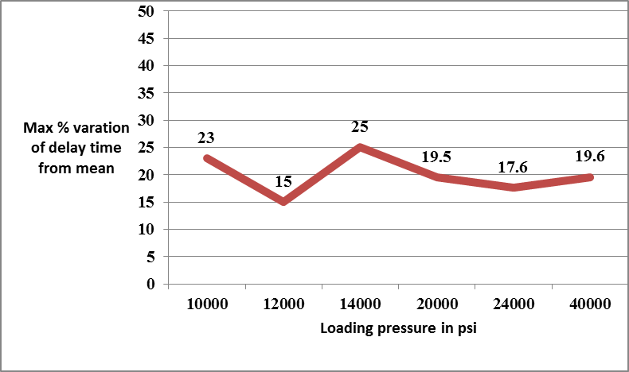

Figure I. Plot of Maximum percent variation of delay time from mean against applied loading pressure

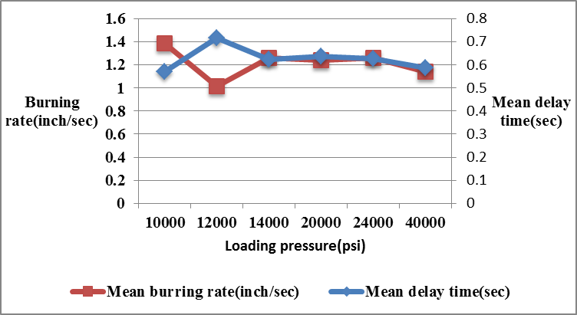
Figure II. Plot of burning rate and delay time against applied loading pressure

3.1.2 Test results of composition Manually Mixed in Mortar and Pestle:

The ingredients of the pyrotechnic composition was mixed in Mortar and Pestle, the mixing procedure has been discussed in Para 2.2.2. The composition was then loaded in the delay body with internal diameter and length of 0.157 and 0.787 inch respectively. The composition was then consolidated at 30,000 psi by using oil operated hydraulic press with calibrated pressure gauge. The dwell time of two sec was applied for each increment. Results in the “Figure III” and “Figure 1V” show that, the variation in delay time of each sample range from 0.162 to 4.376 %. Results also show that burning rate of the delay mixture varies from 1.222 inch/sec to 1.335 inch/sec. The mean delay time and burning rate are 0.617 sec and 1.276 inch/sec respectively. The standard deviation in delay time and burning rate are 1.316 and 0.0269 respectively. The maximum variation in delay time reduced from 25% to 8.75%. The intimate contact of the fuel and oxidizers resulted in the reduction in delay time variation. The intimate contact was ensured through manual dry mixing in Mortar and pestle followed by wet mixing. Additionally the laboratory operating conditions i.e. Controlling dry mixing time, wet mixing, drying time, stabilizing the composition for a specific time, controlling the weighing of the individual ingredients, controlling the weighing of delay composition, using calibrated measurement equipment were also ensured. Homogeneity and intimate contacts of ingredients played a key role in time reproducibility of this pyrotechnic delay composition. Intimate contacts of ingredients was ensured by dry mixing of fine and uniform particles sizes of the fuel and oxidizers followed by wet mixing binder solution. Dry mixing of the ingredients is not very safe method as compared to automatic mixing, therefore safety precautions were ensured during this critical operation. The composition was slurried and the slurry was stirred thoroughly to ensure even distribution of the fuel and oxidizers. The fuels and oxidizers have different densities and if binder is not used then the fuel and oxidizer separates due to their difference in densities. The main reason of adding Fish Glue as binder is to protect the fuel and oxidizer from environment effect such as humidity. Additionally binder also increases cohesion between particles of fuels and oxidizers to protect them from being segregation due to their density difference. The grains also provided ease of loading of the composition in the cartridge body

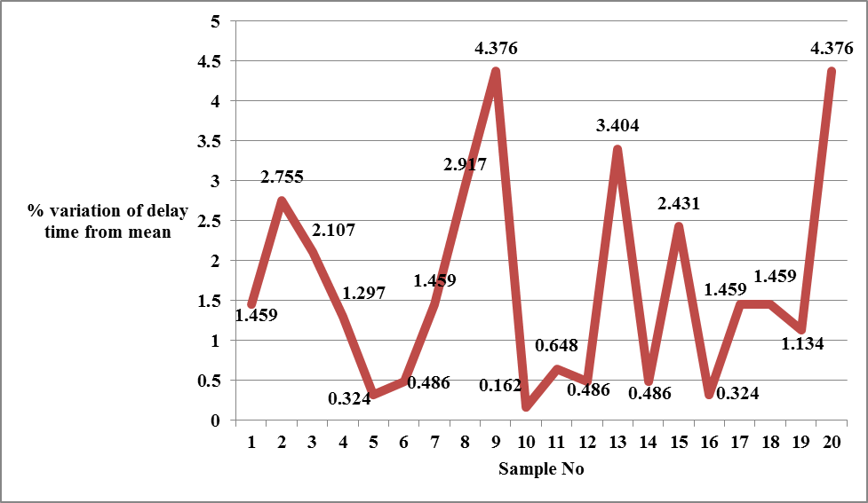

Figure III. Plot of percent variation of delay time from mean for each sample

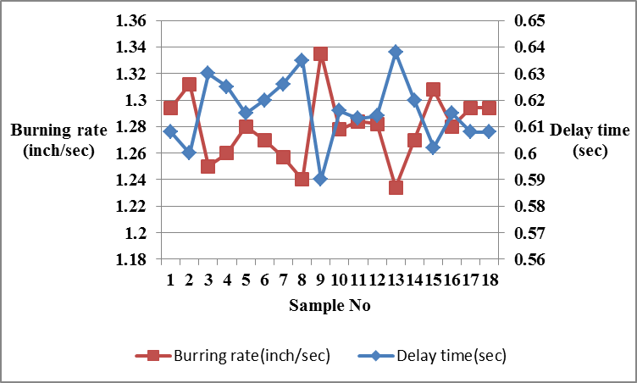

Figure IV. Plot of burning rate and delay time for each sample

3.1.2.1 Effect of loading pressure on delay composition
(Manually Mixed in Mortar and Pestle)

The Data presented in “Table III”, shows that the maximum variation in delay time is from 7.42 to 9.38% by varying the loading pressure from 20000 to 65000 psi. It means that if the composition is homogenously mixed, then this pyrotechnic delay composition is not much effect by the loading pressure and hence the burning rate is relatively insensitive to loading pressure. When the loading pressure was varied from 20,000 to 65,000 psi, only about 2 % variation in mean delay time was recorded. Result in “Table III” also shows that even at 65000 psi, the composition did not become insensitive, ignited by the standard percussion primer and functioned successfully.

Table III. Test results of delay time at different loading pressure

S# | Mean delay time(sec) | Maximum %Variation in delay time | Mean burring rate(inch/sec) | Loading pressure(psi)
1 | 0.635 | 8.66 | 1.240 | 20000
2 | 0.629 | 9.38 | 1.252 | 24000
3 | 0.617 | 8.75 | 1.276 | 30000
4 | 0.634 | 7.42 | 1.242 | 60000
5 | 0.618 | 7.93 | 1.274 | 65000

- Conclusions

The analysis of all these result showed that ingredients mixing along with controlling the laboratory operating conditions are the critical parameters to control the delay time variation and burning rate of pyrotechnic delay composition in a delay device provided that the variation in internal bore size and length of the delay tube is controlled. The manual mixing is much better than mixing in automatic tumbler mixer because the tumbler mixer did not produce intimate contact of the ingredients. The delay time and burning rate of this pyrotechnic delay composition was also not much effected by the varying the loading pressure. Only about 2 % variations in mean delay time was recorded when the loading pressure was varied from 30000 to 65000 psi. These experimental results can be applied as design guidelines for developing of any pyrotechnic delay composition.

- References

[1] J. C. Poret, A. P. Shaw, C. M. Csernica, K. D. Oyler, J. A. Vanatta, G. Chen, “Versatile Boron Carbide-Based Energetic Time Delay Composition”, J. ACS Sustainable Chem. Eng., Vol.1, pp.1313-1338, 2013
[2] H. Ren, Q.Jiao. S.C Chen, “Mixing Si and carbon nanotubes by a method of ball-milling and its application to pyrotechnic delay composition”, J. of physic and chemistry of Solid., Vol. 71, pp. 145–148, 2010
[3] N Davies, Pyrotechnics Hand Book, the Ammunitions Systems and Explosives Technology Department, Cranfield University, 2002
[4] A. Bailey, S.G. Murray, Explosives, Propellant and Pyrotechnics, Royal Military College of Science, Shrivenhan, UK, 1989
[5] Clifford Gordon Morgan, Production of pyrotechnic delay composition, US Patent 0314397 A1, 2009
[6] J A. Conkling, Chemistry of Pyrotechnics Basic Principles and Theory, Department of Chemistry Washington College Chestertown, Maryland, 1985
[7] L. Kalombo, “Evaluation of Bi₂O₃ and Sb₆O₁₃ as oxidants for silicon fuel in the delay detonators”, pp. 50-74, 2005
[8] R. Aube and Lachute (CA), Delay composition and Detonation Delay Device Utilization, Patent-US 0223242 A1 (2008).
[9] B. J. and K. L. Kosanke, “Control of Pyrotechnic Burn Rate”, Second International Symposium on Fireworks, pp.275-288, 1994
[10] Y. Li, Y. Ceng, Y. Hui, S. Yan “The Effect of Ambient Temperature and Boron Content on the Burning Rate of the B/Pb3O4 Delay Compositions”, Journal of Energetic Materials, Vol.28,pp.77-84,2010
[11] S.M Danali, R.S. Palaiah, K.C. Raha, “Developments in Pyrotechnics”, J. Defense Science., Vol. 60, No. 2, pp.152-158,2010
[12] Military Specification, Manganese Delay Composition, MIL-M-21383A (1976).
[13] Military Specification, Delay Composition T-10, MIL-D-85306A (AS) (1991)
[14] Military Specification, Delay Composition, Tungsten-Fluorocarbon Copolymer, MIL-D-82710(OS), (1984).
[15] Operating instructions, Haver Test Shaker EML 200-89 Digital, (1993).
[16] S. Sabeh, A. Kazraji, G. J. Rees, “The fast pyrotechnic reaction of silicon and red lead”, J. Combust. Flame, Vol. 58, pp.39-143, 1978

